Implementation Plan of Needs Identified in the
Community Health Needs Assessment: Progress Measures
FY16-18

Community Needs Assessment

In 2015, AGH in coordination with the local health departments, neighboring hospitals and community stakeholders, conducted a community needs assessment. The needs assessment is a primary tool used by the Hospital to determine its community benefit plan, which outlines how the Hospital will give back to the community in the form of health care and other community services to address unmet community health needs. This assessment incorporates components of primary data collection and secondary data analysis that focus on the health and social needs of our service area. The Community Health Needs Assessment (CHNA) was approved by the Hospital’s Board of Trustees in May 2016.

Needs Identified

The following “areas of opportunity” represent significant health needs of the community, based on information gathered through the Professional Research Consultants, Inc. and Healthy People 2020.

PRC Assessment | Need
Access to Health Services | -Difficulty getting a physician appointment
Arthritis, Osteoporosis & Chronic Back Conditions | -Prevalence of Sciatica/Chronic Back Pain
Cancer | -Prevalence of Cancer (including skin cancer)
Diabetes | -Prevalence of Diabetes  -Borderline/Pre-Diabetes
Heart Disease & Stroke | -Heart Disease Prevalence  -High Blood Pressure  -High Blood Cholesterol  -Overall Cardiovascular Risk
Immunizations & Infectious | -Hepatitis B Vaccination
Injury & Violence | -Use of Seatbelts
Nutrition, Physical Activity & Weight | -Prevalence of Obesity & Overweight  -Meeting Physical Activity Guidelines  -Lack of Leisure Time Physical Activity
Oral Health | -Regular Dental Care
Respiratory Disease | -COPD  -Asthma Diagnosis
Bold = Priorities addressed in Implementation Plan
Italicized = Priorities not addressed in Implementation Plan

The following areas of health concerns were gathered through the Community Health Needs Assessment (CHNA) Survey. Areas are listed according to community priority.

 | CHNA Survey
1 | Cancer  (same as FY13)
2 | Overweight/Obesity  (same as FY13)
3 | Diabetes/Sugar  (up one from FY13)
4 | Heart Disease  (down two from FY13)
5 | Smoking, drug or alcohol use
6 | High Blood Pressure/Stroke  (same as FY13)
7 | Mental Health
8 | Access to Healthcare/  No Health Insurance
9 | Asthma/Lung Disease
10 | Dental Health
11 | Injuries
12 | HIV & STD (<2% ea)
Bold = Priorities addressed in Implementation Plan
Italicized = Priorities not addressed in Implementation Plan

Prioritized Needs

The identified needs were prioritized based on the following criteria: size and severity of the problem determined by what percentage of the population is affected by risks; health system’s ability to impact the need; availability of resources. Based on those criteria several areas were chosen to be the most important for the hospital to focus on.

Priority Areas
Access to Health Services
Cancer
Respiratory Disease and Smoking
Nutrition, Physical Activity & Weight
Diabetes
Heart Disease & Stroke
Mental Health
Opioid Abuse
Arthritis, Osteoporosis & Chronic Back Pain

Implementation Plan

Priority Area: Access to Health Services

Goal: Increase community access to comprehensive, quality health care services.

Healthy People 2020 Goal: Improve access to comprehensive, quality health care services.

Action:
- Partner with poultry plants to promote wellness
- Provide community health events to target minority populations
- Partner with homeless shelters and food pantries to promote wellness
- Utilize Faith-based Partnerships, to provide access to high risk populations for education about healthy lifestyles and chronic disease management
- Educate community on financial assistance options
- Educate community on ED appropriate use
- Increase the number of practicing primary care providers and specialists to community
- Participate on Lower Shore Dental Task Force
- Participate on Worcester County Healthy Planning Advisory Council
- Participate on Homelessness Committee
- Refer community to local agencies such as Shore Transit and Worcester County Health Department for transportation assistance
- Participate on Tri County Health Planning Council

Measurement:
- AGH databases on ethnicity
- Healthy People 2020 https://www.healthypeople.gov/2020/topics-objectives/topic/Access-to-Health-Services/objectives
- Community Survey
- Maryland SHIP http://dhmh.maryland.gov/ship/Pages/home.aspx
- CHSI http://wwwn.cdc.gov/CommunityHealth/profile/currentprofile/MD/Worcester/10019

Healthy People 2020
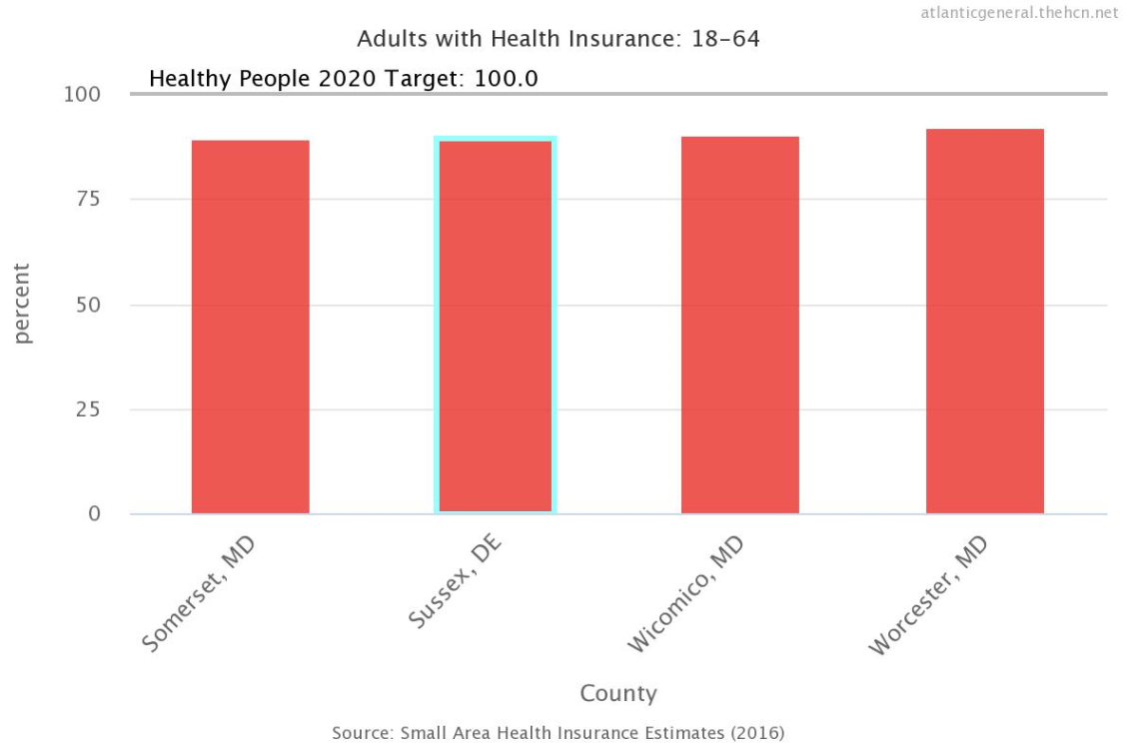

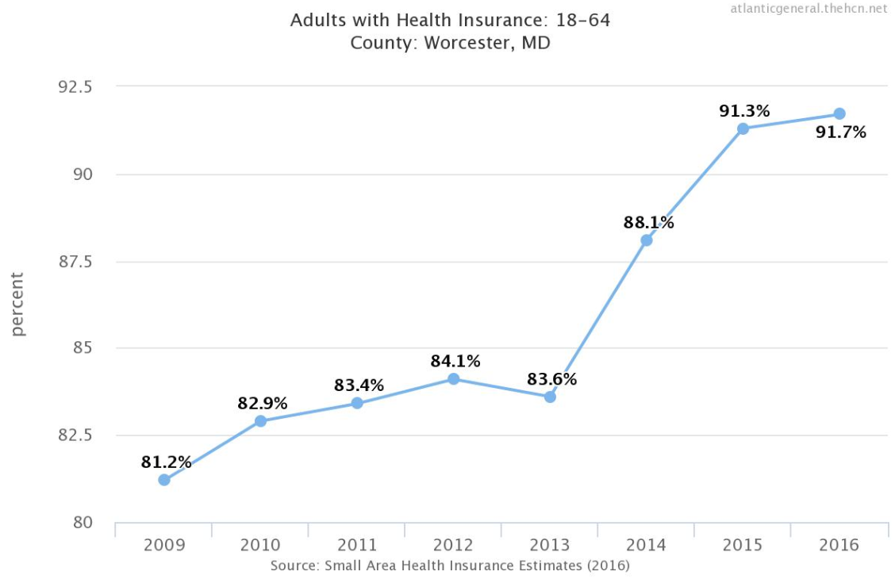

MD SHIP Summary

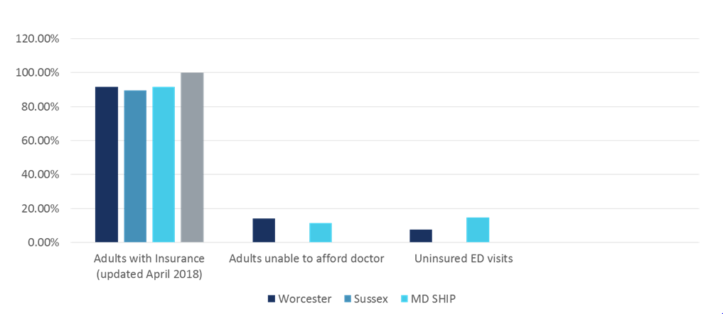

AGH Databases on Ethnicity and Community Survey – repeat in FY19 to compare

CHSI
Effective 2017, Community Health Status Indicators 2015 (CHSI) no longer available
https://www.cdc.gov/ophss/csels/dphid/CHSI.html

Priority Area: Cancer

Goal: Decrease the incidence of advanced breast, lung, colon, and skin cancer in community.

Healthy People 2020 Goal: Reduce the number of new cancer cases, as well as the illness, disability, and death caused by cancer.

Action:
- Recruit proper professionals in community to provide for cancer related treatment
- Provide community health screenings
- Partner with local health agencies to facilitate grant application to fund cancer programs
- Improve proportion of minorities receiving colonoscopy screenings
- Improve proportion of minorities receiving LDCT screenings
- Improve proportion of minorities receiving women’s preventative health services
- Increase the proportion of persons who participate in behaviors that reduce their exposure to harmful ultraviolet (UV) irradiation and avoid sunburn through melanoma education and skin cancer screenings.

Measurement:
- Healthy People 2020
https://www.healthypeople.gov/2020/topics-objectives/topic/cancer/objectives
- AGH databases on ethnicity
- Maryland SHIP http://dhmh.maryland.gov/ship/Pages/home.aspx*
- CHSI http://wwwn.cdc.gov/CommunityHealth/profile/currentprofile/MD/Worcester/310034

Progress Measurements:

Healthy People 2020
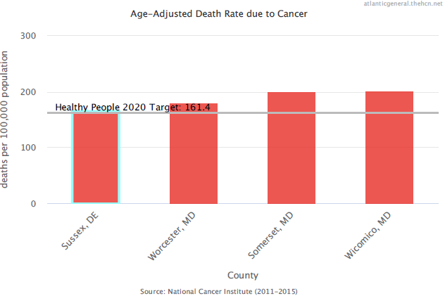

MD SHIP 2017
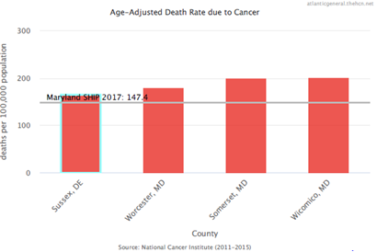

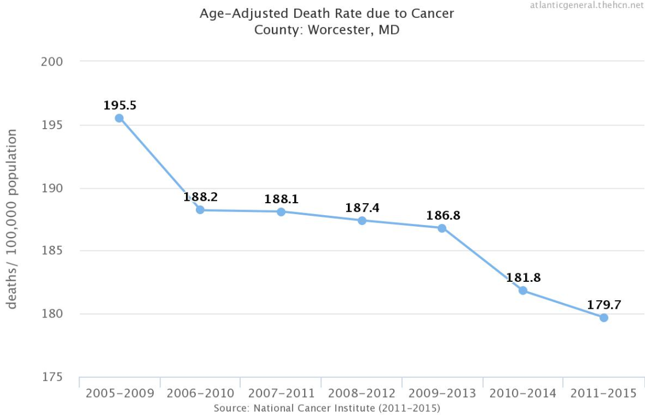

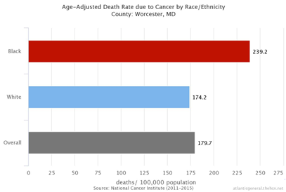

AGH Internal Data
- Melanoma remains #1 cancer seen in AGH ED FY16-18
- Lung cancer remains highest mortality among African American males
FY16-18 – advanced stage diagnosis
- RCCC Capital Campaign
- Before AGH began their lung cancer screening program, 88% of all lung cancer patients were diagnosed at the most advanced stage. That percentage has been steadily decreasing, and last year only 36% of patients diagnosed with lung cancer had an advanced stage. In 2017, 157 patients participated in being screened for lung cancer and continue to be followed at appropriate intervals.
- Community free cancer screening events - >500 persons served
- Community cancer prevention education events - >50 events
AGH Database on Ethnicity – compare to FY19

CHSI
Effective 2017, Community Health Status Indicators 2015 (CHSI) no longer available
https://www.cdc.gov/ophss/csels/dphid/CHSI.html

Priority Area: Respiratory Disease, including Smoking

Goal: Promote community respiratory health through better prevention, detection, treatment, and education efforts.

Healthy People 2020 Goal: Promote respiratory health through better prevention, detection, treatment, and education efforts.

Action: Recruit Pulmonologist to community
- Improve proportion of minorities receiving LDCT screenings
- Collaborate with Worcester County Health Department Prevention Department
- Reduce emergency department (ED) visits for chronic obstructive pulmonary disease (COPD) and asthma
- Provide speakers to community groups on smoking cessation
- Participate in community events to spotlight pulmonary clinic services
- Improve Health Literacy in middle schools related to tobacco use

Measurement:
- Healthy People 2020 Objectives
https://www.healthypeople.gov/2020/topics-objectives/topic/respiratory- diseases/objectives
- Decrease ED visits due to acute episodes related to respiratory condition
- CHSI http://wwwn.cdc.gov/CommunityHealth/home
- Maryland SHIP http://dhmh.maryland.gov/ship/Pages/home.aspx
Progress Measurements:

Healthy People 2020
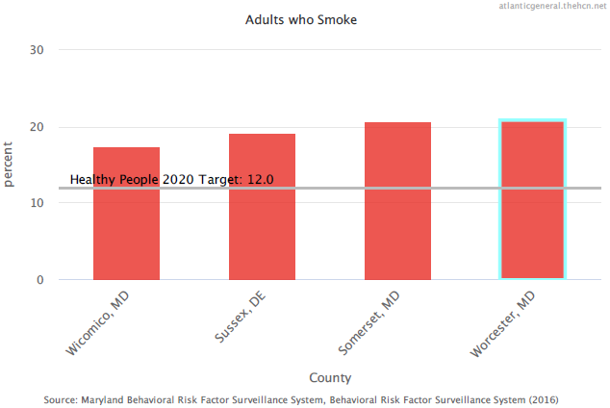

AGH Internal Data – ED Visits
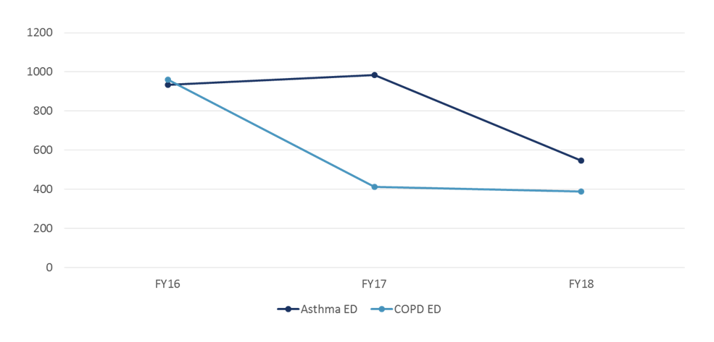

Community Data Summary – BRFSS and MD SHIP
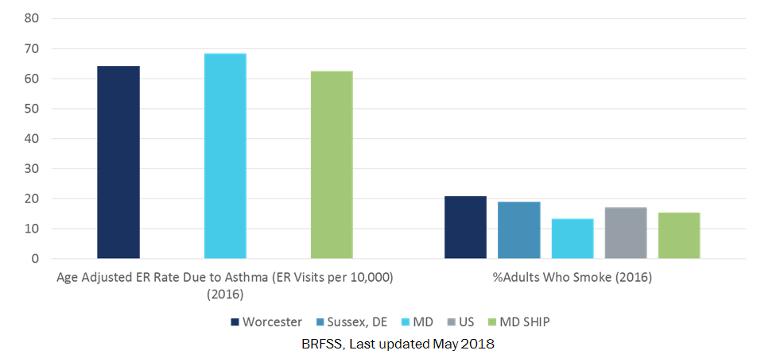

CHSI
Effective 2017, Community Health Status Indicators 2015 (CHSI) no longer available
https://www.cdc.gov/ophss/csels/dphid/CHSI.html

Priority Area: Nutrition, Physical Activity & Weight

Goal: Support community members in achieving a healthy weight.

Healthy People 2020 Goal: Promote health and reduce chronic disease risk through the consumption of healthful diets and achievement and maintenance of healthy body weights.

Action:
- Improve Health Literacy in elementary and middle schools related to nutrition and exercise
- Participate in the “Just Walk” program of Worcester County
- Distribution brochure to public about Farmer’s Market & fresh produce preparation
- Integrate Healthy People 2020 objectives into AGHS offices
- Provide Hypertension and BMI screenings in the community
- Provide speakers to community groups on nutrition
- Continue to provide education on health living topics to Faith-based Partnership and community senior centers
- Participate in community events to spotlight surgical and non-surgical weight loss services
Measurement:
- Healthy People 2020 Objectives
https://www.healthypeople.gov/2020/topics-objectives/topic/nutrition-and-weight-
status/objectives
- County Health Rankings
- Maryland SHIP http://dhmh.maryland.gov/ship/Pages/home.aspx

Progress Measurements:

Healthy People 2020
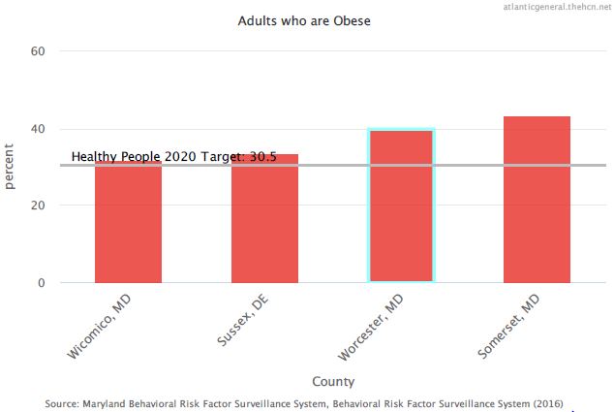

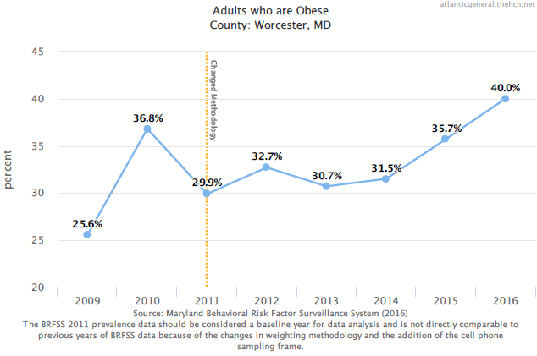

MD SHIP
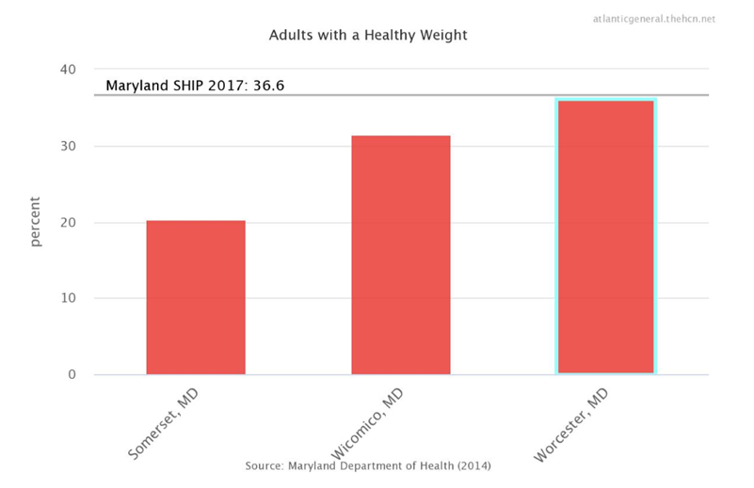

Priority Area: Diabetes

Goal: Decrease incidence of diabetes in the community.

Healthy People 2020 Goal: Reduce the disease and economic burden of diabetes mellitus (DM) and improve the quality of life for all persons who have, or are at risk for, DM.

Action:
- Continue to provide Diabetes Education in Patient Centered Medical Home
- Partner with local health agencies to facilitate grant applications to fund diabetes programs
- Participate on Tri-County Diabetes Alliance
- Provide diabetes screenings in community
- Increase prevention behaviors in persons at high risk for diabetes with prediabetes
- Recruit Endocrinologist to community

Measurement:
- Healthy People 2020 Objectives https://www.healthypeople.gov/2020/topics-objectives/topic/diabetes/objectives
- Incidence of adult diabetes
- Decrease ED visits due to acute episodes related to diabetes condition
- County Health Rankings
- Maryland SHIP http://dhmh.maryland.gov/ship/Pages/home.aspx
Progress Measurement:

MD SHIP
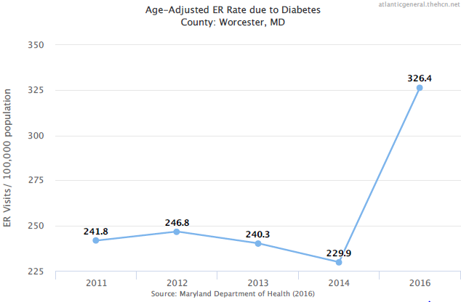

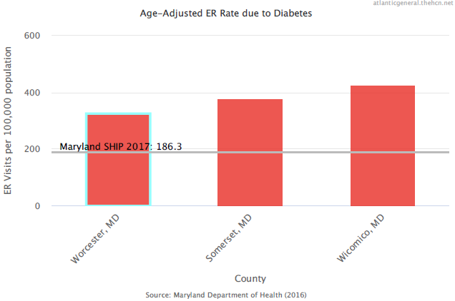

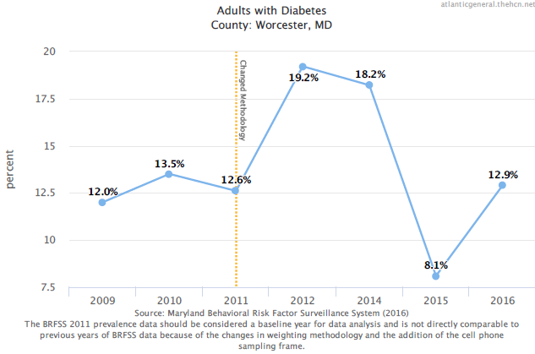

Priority Area: Heart Disease & Stroke

Goal: Improve cardiovascular health of community.

Healthy People 2020 Goal: Improve cardiovascular health and quality of life through prevention, detection, and treatment of risk factors for heart attack and stroke; early identification and treatment of heart attacks and strokes; and prevention of repeat cardiovascular events.

Action:
- Ensure proper professionals in community to provide vascular care
- Maintain AGH/HS campus and locations as tobacco free
- Increase community health screenings for high blood pressure, carotid artery and cholesterol
- Decrease readmissions to hospital for chronic disease management
- Utilize Faith Based Partnerships, to provide access to high risk populations for education about healthy lifestyles and chronic disease management
- Improve Health Literacy in elementary and middle schools related to heart health

Measurement:
- Healthy People 2020 https://www.healthypeople.gov/2020/topics-objectives/topic/heart-disease-and-stroke/objectives
- Readmission rate
- MD SHIP

Progress Measurement:
Healthy People 2020
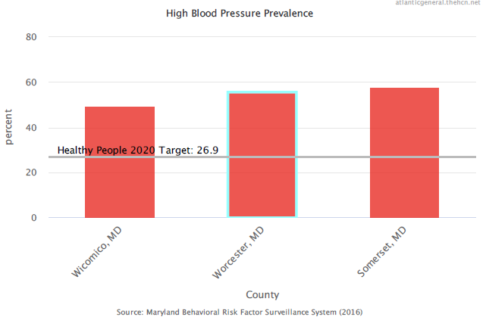

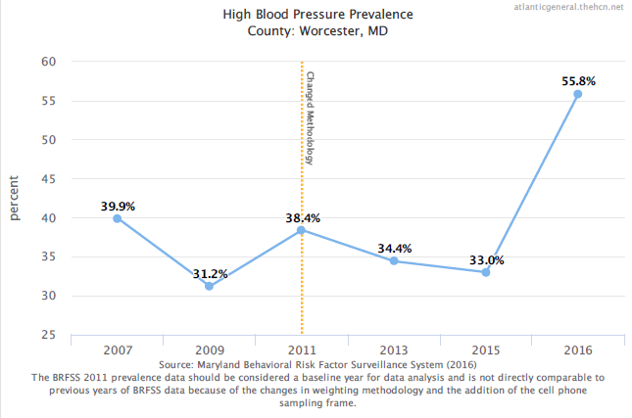

MD SHIP
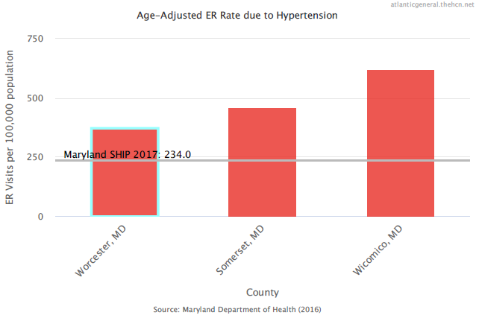
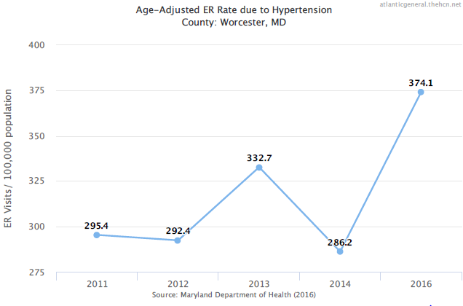

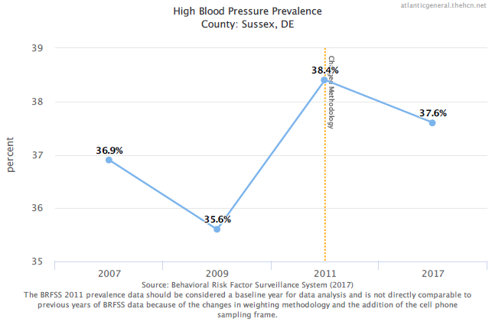

AGH Internal Data
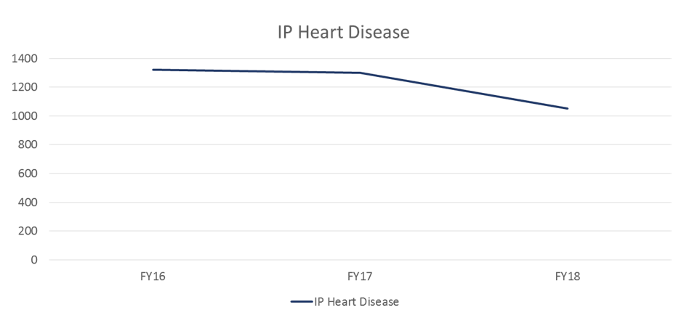
Priority Area: Mental Health

Goal: Promote and ensure local resources are in place to address mental health.

Healthy People 2020 Goal: Improve mental health through prevention and by ensuring access to appropriate, quality mental health services.

Action:
- Increase access and continue to collaborate with Sheppard Pratt telemedicine services to provide additional psychiatry professional
- Participate in community events to spotlight mental health services
- Engage critical response teams when a mental health crisis is discovered
- Improve Health Literacy in middle schools related to mental and emotional health
- Recruit Psychiatrist to the community

Measurement:
- Healthy People 2020 https://www.healthypeople.gov/2020/topics-objectives/topic/mental-health-and-mental-disorders
- Behavioral Risk Factor Surveillance System
- County Health Rankings
- MD SHIP

Healthy People 2020

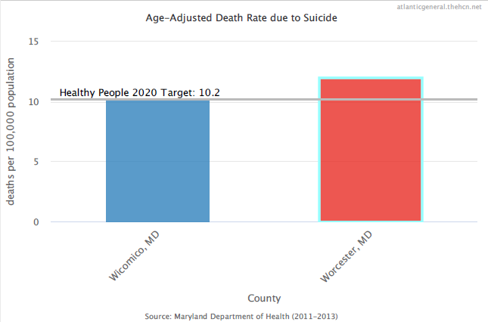

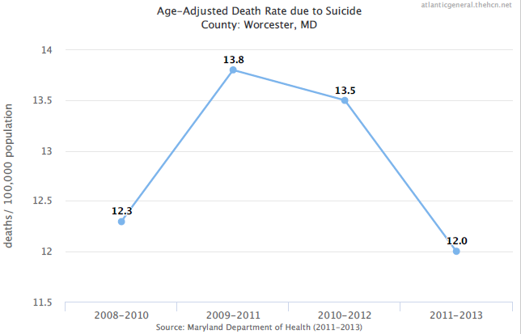
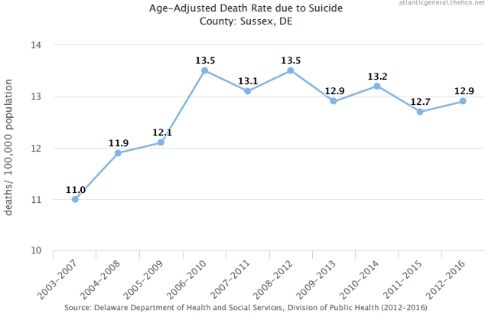
MD SHIP
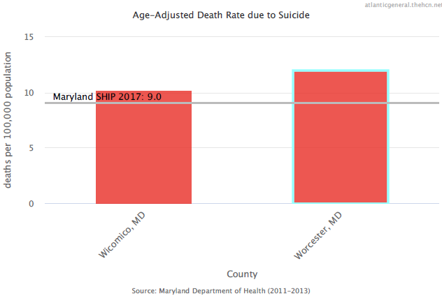
BRFSS
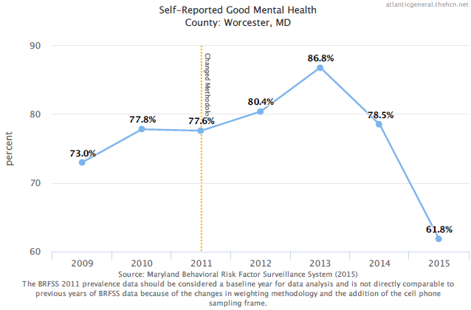
Priority Area: Opioid Abuse

Goal: Reduce opioid substance abuse to protect community health, safety, and quality of life for all.

Healthy People 2020 Goal: Reduce substance abuse to protect the health, safety, and quality of life for all, especially children.

Action:
- Participate on WOW Committee
- Participate on Opioid Task Force
- Increase Health Literacy in middle schools r/t opioid use
- Provide educational opportunities to raise community awareness about opioid use
- Participate in Worcester County Health Department naloxone training sessions sponsored by Opiate Overdose Prevention Program
- Increase the proportion of persons who are referred for follow-up care for opioid problems after diagnosis, or treatment for one of these conditions in a hospital emergency department (ED)
- Evaluate and educate organization and community on appropriate prescribing practices
- Implement Prescription Drug Maintenance Program (PDMP) via CRISP

Measurements:
- Community Survey
- Healthy People 2020 https://www.healthypeople.gov/2020/topics-objectives/topic/substance-abuse
- Pain management referrals

Healthy People 2020
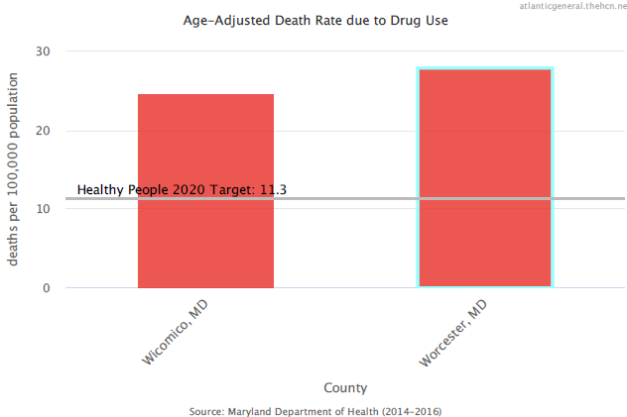
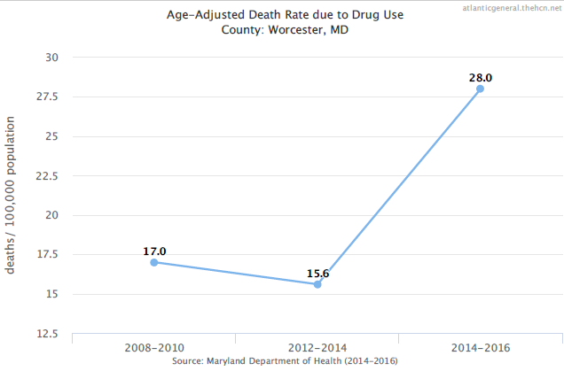

Pain Management Referrals- AGH Internal Data
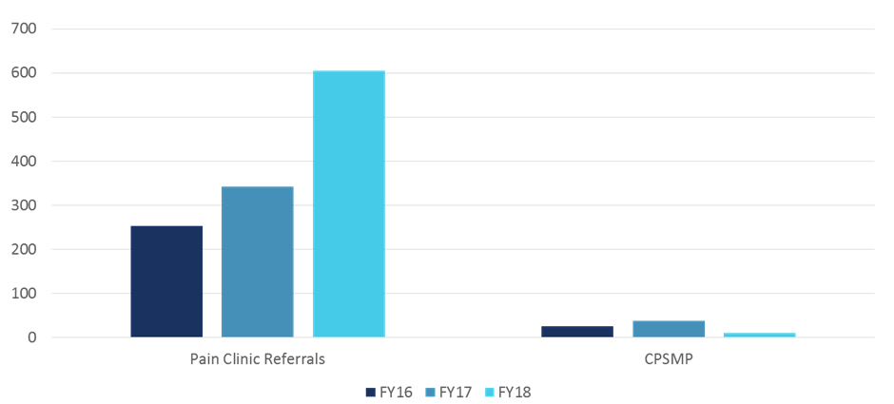

Community Survey – compare to FY19

Priority Area: Arthritis, Osteoporosis & Chronic Back Pain

Goal: Prevent illness and disability related to arthritis and other rheumatic conditions, osteoporosis, and chronic back conditions in the community.

Healthy People 2020 Goal: Prevent illness and disability related to arthritis and other rheumatic conditions, osteoporosis, and chronic back conditions.

Action:
- Utilize Faith Based Partnerships, to provide access to high risk populations for education about healthy lifestyles and chronic pain workshops
- Recruit Rheumatologist to community
- Utilize Women’s Diagnostic Health Services, to provide access to high risk populations about healthy lifestyles and bone density screenings
- Implement Osteopenia Intervention Program
- Provide educational opportunities to raise community awareness about osteopenia/osteoporosis and provide bone density screenings
- Increase accurate and up-to-date information and referral service
Measurements:
- Healthy People 2020 https://www.healthypeople.gov/2020/topics-objectives/topic/Arthritis-Osteoporosis-and-Chronic-Back-Conditions
- CPSMP Workshop attendance
- Community Survey

Progress Measurements:

CPSMP Workshop attendance 281 encounters FY16-18 (Source: AGH Internal Data)
Community Survey – repeat in FY19 to compare

Healthy People 2020
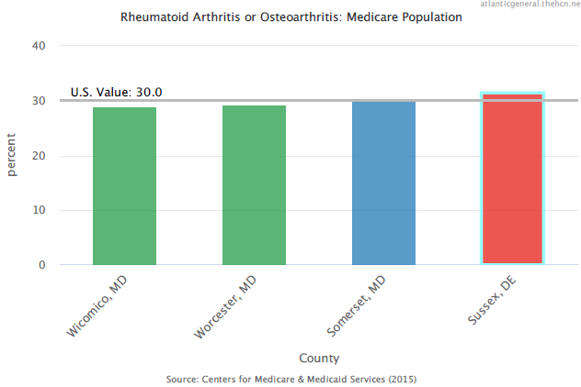

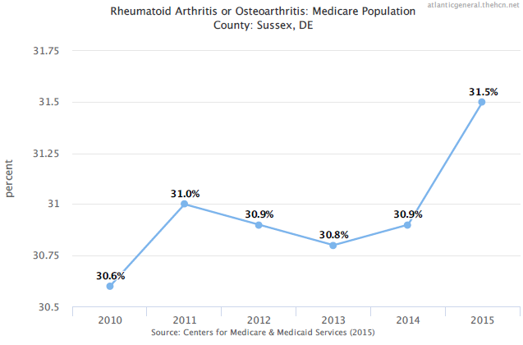
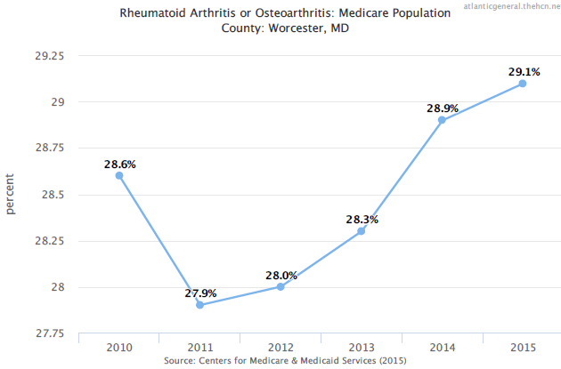

MD SHIP
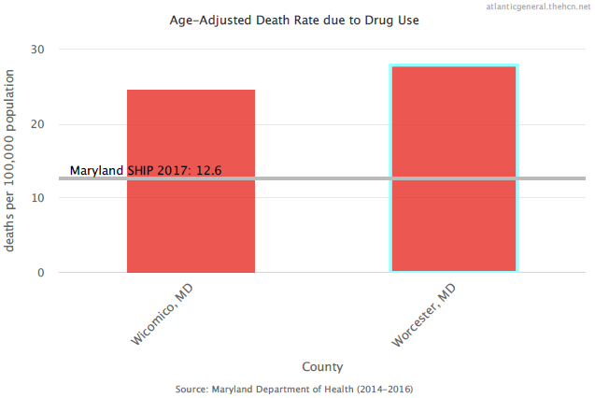

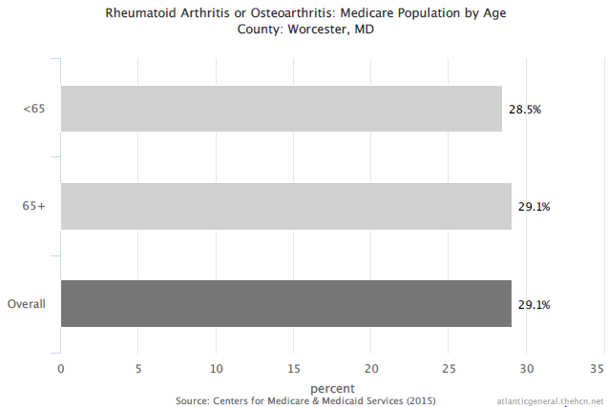

Strategic Vision 2020

Continuing to build upon our Mission “To create a coordinated care delivery system that will provide access to quality care,” the AGH 2020 Vision will drive strategic decisions toward integration beyond the acute care facility. These decisions will build upon the current investments in developing community-based care delivery systems that incorporate primary care, specialty care, and care management of chronic conditions through our PCMH.
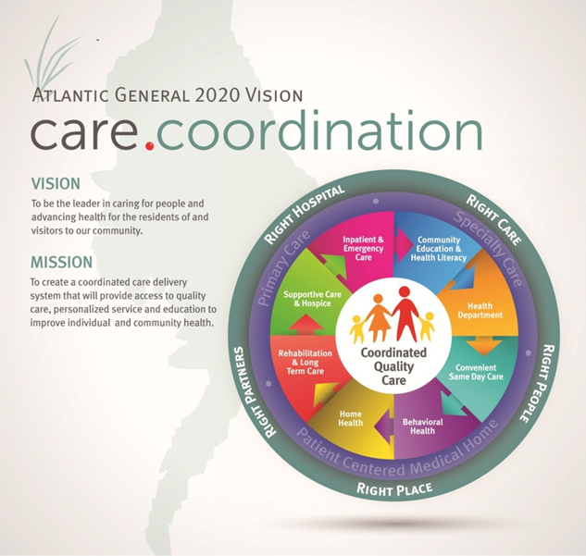

Accomplishing our Vision will require disciplined investment of time and resources in the “Right” principles:
Right Care - Patient/Family Centric, Error Free, Primary Care Provider-Driven, Timely Delivery, Best Practice Protocols;
Right People – Needs-Based Provider Recruitment, Service Orientation, Right Training, Continuous Learning;
Right Place – Appropriate Distribution of Primary Care, Availability of Specialists, Telemedicine, Community-Based vs. Hospital Based;
Right Partners – Advanced Acute Care Referral Relationships, Rehabilitation Care, Long-Term Care, Home Health Care, Supportive Care/Hospice, Mental Health Care, Accountable Care;
Right Hospital – The Right Leader for Coordinated Quality Care in our Community.

Our “2020 Vision” will build upon our distinctive competencies to create a new system of health. Investment in technology-based solutions will facilitate care being distributed more evenly throughout our region, creating equity in access to all. Building upon our health literacy initiatives and our relationship with the Worcester County Health Department, AGH will be a leader in addressing the individual factors that affect health promotion and prevention of disease. Continuing to promote health care interventions driven by patient-centered values to improve individual function and well-being will result in improved quality of life for those who choose to live in our community.

Strategic Implications:

Building upon our previous Strategic Plans, we will focus on:

- Continued collaboration with local, state and community partners;
- Prioritizing capital investment in areas of IT, such as PERKS Optimization and Telemedicine, that will overall improve coordination of care, quality of care, and efficiency for the patient;
- Creating a collaborative care model for the delivery of care within the hospital and with pre- and post-acute care providers, in an electronic environment;
- Measuring patient outcomes throughout the system by establishing optimal health and wellness goals for patients;
- Reducing unnecessary steps throughout our system to optimize the patient experience, reduce opportunity for errors, and enhance economic stability.

A primary clinical component of this strategy that will be achieved through the continued integration of clinical care, IT, physician practice and patient involvement is the AGH Patient Centered Medical Home Model. Other coordinated care efforts include AGH Ambulatory Pharmacy Transitions in Care Program and the AGH Perioperative Surgical Home Model. Achievement of each collaborative care delivery model for those in our community with chronic illnesses, medication management needs and/or surgical services will improve access to care, reduce unnecessary visits to our ED and unnecessary admissions, and provide a continuous virtual connection for those utilizing AGH/HS services.

Other needs identified in the CHNA but not addressed in this plan

Each of the health needs listed in the Hospital’s CHNA as well as Worcester County Health Department’s Community Needs Assessment is important and is being addressed by numerous programs and initiatives operated by the Hospital and/or other community partners of the Hospital. Needs not addressed as a priority area in the Implementation Plan are being addressed in the community by other organizations and by organizations better situated to address the need.

Needs Not Addressed In Plan | Rationale
Dental/Oral Health | -Need addressed by Worcester County Health Department’s Dental Services for pregnant women and children less than 21 years of age  -Priority Area Worcester CHIP  -Need addressed by Lower Shore Dental Task Force & Mission of Mercy for adult population  -Need addressed by AGH ED referral to community resources  -Need addressed by La Red Sussex County  -Need addressed by TLC, a federally funded dental clinic for Somerset and Wicomico Counties
Injury & Violence | -Need addressed by Worcester County Health Department Programs:  Child Passenger Safety Seats  Injury Prevention  Highway Safety Program  Safe Routes to School  -Need addressed by Worcester County Sheriff’s Department, State Police and Municipal Law Enforcement Agencies  -Need addressed by AGH Health Literacy Program
Immunizations & Infectious | -Need addressed by Worcester County Health Department Programs:  Immunization Program  Communicable Disease  -Priority Area Worcester CHIP  -Need addressed by DHMH World Hepatitis Day
HIV & STD (<2% ea) | -Need addressed by Worcester County Health Department Communicable Disease Programs
Alcohol | -Need addressed by Worcester County Health Department Behavioral Health and Prevention Services Addictions Program  -Need addressed by local AA organization  -Need addressed by Drug and Alcohol Council

References

Atlantic General Hospital. Creating Healthy Communities. http://www.atlanticgeneral.org/Community-Health-Wellness/Creating-Healthy-Communities.aspx?hcn=CommunityDashboard

CDC National Center for Health Stats (2015). Retrieved from http://www.cdc.gov/nchs/fastats

CDC Diabetes Public Health Resource (2014). Diabetes Public Health Resource (1980 – 2014). Retrieved from http://www.cdc.gov/diabetes/statistics/prev/national/figpersons.htm

CDC Heart Disease Statistics and Maps (2015). Retrieved from http://www.cdc.gov/HeartDisease/facts.htm

CHSI (2015). Community Health Status Indicators 2015. Retrieved from http://wwwn.cdc.gov/CommunityHealth/profile/currentprofile/

Community Health Needs Assessment FY2016-FY2018

County Health Rankings (2016). Worcester County, Maryland, Sussex County, Delaware Data. Retrieved on August 25, 2016, from http://www.countyhealthrankings.org/app/

Healthy People 2020

NCI (2015). National Cancer Institute: Obesity, National Institute of Health. Retrieved on August 25, 2016, from http://www.cancer.gov/about-cancer/causes-prevention/risk/obesity

MD SHIP

Mental Health Surveillance (2013). CDC. Retrieved on August 30, 2016, from https://www.cdc.gov/mentalhealthsurveillance/

PRC Survey (2015). Professional Research Consultants, Inc.

State Cancer Profiles (2009-2013) Healthy People 2020 Objective Number: C-8 Reduce the melanoma cancer death rate. Retrieved from https://statecancerprofiles.cancer.gov/cgi-bin/deathrates/deathrates.pl?10&053&00&0&001&0&1&1&1#results

