
Please be aware that the following information needs to be sent to our office prior to your Bariatric Consult with the surgeon. If we do not have the information, your appointment may need to be rescheduled until it is obtained. Thank you.

- Last office note from your PCP within the past 6 months.
- Any recent bloodwork results, or ECG performed within the past 3-6 months.
- Any recent imaging tests (i.e. UGI, EGD, Abdominal Ultrasound) performed within the past 6 months
- If you have imaging tests that were not performed at AGH, please bring the CD with you on the day of your consult.
- Any recent Sleep Study tests performed.
- If you are currently in another Bariatric Program and/or seeing a Dietitian, we will require the office notes or documentation.
- If you are seen by a specialist (i.e. cardiologist, endocrinologist, nephrologist, etc.) we would like the most recent office note.
- If you have had prior bariatric surgery, we need the operative report to inform us as to where, when, type, and by whom your procedure was performed.
- If your insurance requires a referral, please have it faxed to us. This is usually obtained from your PCP. Without the proper referrals, you can be held responsible for payment of visits.

Information can be faxed to our office at 410-641-1006. Please contact our office during the hours of Monday-Friday from 8am-4pm at 410-641-9568 prior to your consult to ensure that we have all necessary information to keep your appointment. Any questions regarding billing and/or surgery cost can be answered by contacting our physician billing department at
410-641-9450 or patient financial services at 410-641-9606


Coverage for weight loss surgery and preparation for surgery vary greatly from policy to policy. This document is designed to help you determine your level of coverage and the requirements of your individual plan. Start by calling the # on the back of your insurance card. Ask to speak with a “benefits” representative about “prior authorization” for bariatric surgery.
Insurance Company Representative’s Name:
Policy Number:
Ask the representative the following:
- Does my policy cover:
- Laparoscopic Roux-en-Y (CPT code 43846/43644) Yes / No
- Laparoscopic Gastric Band (CPT code 43770) Yes / No
- Laparoscopic Sleeve Gastrectomy (CPT code 43775) Yes / No
- If the answer is No, ask if there are any exemptions for medical reasons such as Diabetes or High Blood Pressure.

- What are the requirements to be authorized for surgery?
- Do I need medically supervised weight loss attempts? Yes / No
- If Yes, for how long & do they need to be consecutive?
- Do I need a Psychological evaluation? Yes / No
- Do I need specific studies (i.e. UGI, Labs)? Yes/ No
- Do I need to journal food/exercise? Yes / No
- Does my surgery need to take place at a specific type of hospital (i.e. A Center of Distinction)? Yes/ No

- Do they cover Nutritionists/Dietitian visits? Yes / No
- If Yes, do they cover services provided by Atlantic General Hospital? Yes / No

- Does insurance cover medical supervision of treatment programs? Yes / No

- Do I need a referral for initial consultation with the surgeon, nutritionist, or psychologist/mental health professional? Yes/ No

Pre-Surgical Bariatric Program Expectations
- Contact your insurance provider to obtain coverage information for bariatric surgery and dietary visits. This helps you as the patient clarify what is required of you in order to qualify for bariatric surgery.
- Attend an initial appointment with the surgeon for evaluation. The surgeon must be made aware of & will need to review any records from previous bariatric surgery.
- Complete required education & implement personalized plan regarding the following: Dietary Counseling, Psychiatric Evaluation, Physical Activity/Weight loss prior to surgery, Support Group Attendance, & “Other” requirements. Read below for more details:
- Dietary Counseling- Attend 3-6 visits with the dietitian, depending on insurance. Most insurance companies require 6 visits, however Medicare requires only 3. For those needing 6, your initial & last visits will be one on one with you & the dietitian. The middle visits will be in a group setting. Medicare patients’ visits will all be one on one with the dietitian. See Nutrition requirements for more info.
- Psychiatric Evaluation- Complete a Psychiatric Evaluation to ensure there are no contraindications for bariatric surgery from a mental health standpoint (i.e. history of eating disorder). We can provide a list of local mental health providers for those patients who need this resource. Please ask at the front desk for the list. Also, included in this seminar packet is a list of psychiatric considerations recommended for the mental health provider to include in his or her assessment note.
- Weight loss prior to surgery (usually 5% of total weight___). BMI must be <60 prior to surgery. It is highly recommended that you keep a food & exercise journal. You may not gain weight during your program.
- Support Group Attendance- Each patient is encouraged to attend 3 support group meetings to augment their formal dietary counseling. Research shows this is helpful.
- Other possible individual requirements- Complete Sleep Study, & Pulmonary & /or Cardiac Clearance (if deemed necessary by Dr. Zarif or Dr. Zhong). EKG is frequently required (is required for Priority Partners). EGD is required for revision surgery.
- Patients must also be under the care of a primary care provider for management of all routine medications & conditions. It is also advised that patients be up to date on ALL preventative care prior to surgery (i.e. colonoscopy, breast & GYN exams).
- Note: all patients must be smoke free for 90-days prior to bariatric surgery.
- Attend final pre-surgical appointments with the surgeon, dietitian, & Angela.
*Additional studies and requests may be made on an individual patient basis per surgeon discretion.

Provider Signature Date

Patient Printed Name/ DOB Patient Signature
Post-op Bariatric Program Expectations

Please understand that it is important to maintain a proper follow up period for our Bariatric Program. We want to ensure the success of each of our patients.

In addition, your nutritional health, prior, during, and after the surgery is a major concern to us. We want your experience to be free of complications and make sure that any questions that arise are addressed accordingly, and in a timely manner.

Our Bariatric Program requires that, after surgery, each patient be seen for appointments with the Surgeons, Nurse Practitioner, and/or the Dietitians at timeframes of 1 week, 3 weeks, 6 weeks, 3 months, 6 months, and yearly. We will schedule the 2 week & 6 week visits prior to surgery. As for the 3 month, 6 month, & yearly visits, we would like you to contact our office at 410-641-9568 to schedule these appointments at your convenience. We can be reached Monday through Friday from 8:00AM to 4:30PM EST.

Provider Signature

Patient Name

DOB

Date

Psychological Assessment Considerations Handout for Bariatric Surgery
- Comprehensive psychiatric interview (initial requirement: in person or face to face evaluation, for the purpose of identifying risk factors or potential post-operative challenges that may contribute to a poor post-operative outcome).
- Complete Mental Status Exam (MSE)
- Documentation of all current & previous psychiatric diagnoses, & either: 1. No behavioral health disorder by history, supported by 18 month claims & pharmacy activity, OR 2. If behavioral health disorder by history & claims & pharmacy activity, documentation must indicate all of the following: No active psychosis, & if binge eating disorder diagnosis or symptoms, these have been fully evaluated, treated, & monitored.
- Completion of drug & alcohol screen, which documents all of the following: 1. No drug or alcohol abuse by history supported by an eighteen (18) month claims & pharmacy look back, OR 2. Alcohol & drug free period of a minimum of 1 year
- History of weight loss or gain & maintenance or regain
- Developmental history (family stability or instability, neglect, etc.)
- Traumatic abuse
- Current life stressors
- Psychological/emotional resources & coping styles (internal/external, self-advocating/ path of least resistance)
The purpose of the psychological assessment is to identify risk factors that can allow for the meaningful prediction of complicated or compromised post-bariatric surgery outcomes. The assessment should address whether or not a person is a good candidate for bariatric surgery.
There is no current consistency across evaluators with regard to the breadth, depth or quality of the pre-surgery evaluation or the recommendations &/or requirements for bariatric surgery candidates.
- Mental Health Providers: 1. Lisa Barnes, MSW, LCSW-C (443-366-5606) (Telehealth ONLY), 2. Evolve Mental Wellness (410-642-4011), 3. Worcester Youth & Family Center- (410-641-4598), 4. Angela Brainard Burke LCPC- Ocean City (410-723-1800)
- For Spanish speaking patients ONLY: The Worcester County Health Department will make accommodations in the office. Please call 410-629-0164
- Patients may also utilize their own mental health provider for evaluations if desired, and if that provider agrees to perform the evaluation.

Name DOB DATE
Nutrition Assessment Form (Fill out & bring in for initial Dietitian visit.)
Current Height: _______ Present Weight: _______ What is your preferred weight?
What is your motivation to lose weight (health related, mobility related, task related, etc)?
What was your highest adult weight & how old were you at that age?
What was your lowest adult weight & how old were you at that age?
With whom do you live? ☐Spouse ☐Family ☐Friend ☐Alone
What is your employment status? ☐Full-Time ☐Part-Time ☐Retired ☐Student ☐Other ___________
If you work, what is your occupation? How many hours do you work?
Have you had previous weight loss surgery? Yes/No If yes, what surgery & when?
List any past diets/weight loss plans:
What age do you feel weight became a concern for you & why?
Briefly describe your past struggles with weight & what you believe has contributed to weight gain or inability to lose weight:
Have you seen a dietitian before? Yes/No If yes: When? Where? Why?
Do you take any supplements or vitamins? If so, please list them.
Food Allergies/ Intolerances/ Preferences (i.e. Peanut allergy, Vegan, Vegetarian, etc)
Do you have a history of an eating disorder? Yes/No Explain
Readiness Assessment

I want to lose weight because:
If I could change 3 things about my health & nutritional habits, they would be:
The biggest challenge(s) to reaching my nutrition/weight loss goals are:
Please check (✓) everything below that describes your personal eating pattern and/or lifestyle behaviors:
I eat large portions, get seconds or overfill my plate. | I don’t take time to plan healthy meals.
I skip meals or go for longer than 5 hours between meals. | I am tempted by family & friends to eat unhealthy foods.
I dine out more than 3 times a week. | I lack the knowledge to cook healthy meals.
I frequently eat fried foods, fast foods, & high fat foods. | I never feel “full” or satisfied after eating.
I frequently eat sweets & desserts (i.e. cookies, candy, cakes). | When dieting, I go to extremes.
I graze or snack on food all day long, especially when doing other things like reading, watching TV, or while on the computer. | I drink less than 64 oz. or 8 cups of fluid daily.
I eat too quickly. | I usually drink two or more alcoholic drinks daily.
I am an emotional eater. (I eat when I’m stressed, bored, sad, angry, anxious, etc.) | My work schedule hinders my weight loss efforts.
I am so busy, I forget to eat or I skip meals. | I would have a difficult time reducing or giving up:
I am a “picky” eater. | Other:

Who buys groceries in your home?
Who prepares meals in your home?
How many times per day do you eat Fruit? Vegetables? Grains? Protein?
How much water or non-caffeinated beverages do you drink per day in oz?
How many times per day do you eat on average? Do you snack in between meals?
Do you engage in physical activity? Yes/No If so, what do you do?
How often do you exercise? How long do you exercise?
Diet Recall for a “typical day”:
Breakfast-
Lunch-
Dinner-
Snacks-
Motivation level to make changes: (1= not motivated at all & 10= very motivated)
Goals:
Increase water intake | Increase fruit & vegetable intake | Stop smoking
Increase overall fluid intake | Increase protein intake & eat protein with each meal | Start exercising
Decrease sugary beverage intake | Choose more whole grains & whole foods | Attend support group meetings
Decrease or stop alcohol intake | Measure portions | Gather information about surgery
Stop soda intake | Plan meals & prepare more meals at home | Engage support system in lifestyle changes

PATIENT NAME: DATE OF BIRTH:

INITIAL VISITS | DATE COMPLETED | PROVIDER SIGNATURE
SEMINAR/WEBINAR
SURGEON CONSULT

*PLEASE REVIEW THE GROUP NUTRITION & SUPPORT GROUP CALENDAR TO GET AN IDEA OF THE DATES YOU WISH TO ATTEND.
*PLEASE SCHEDULE NUTRITION APPOINTMENTS ASAP. SPACE MAY BE LIMITED FOR THESE VISITS. YOU MUST ATTEND (1) NUTRITION VISIT PER MONTH.
NUTRITION VISITS | DATE COMPLETED | PROVIDER SIGNATURE
INITIAL NUTRITION VISIT (1 ON 1)
GROUP OR INDIVIDUAL VISIT # 1
GROUP OR INDIVIDUAL VISIT # 2
GROUP OR INDIVIDUAL VISIT # 3
GROUP OR INDIVIDUAL VISIT # 4
GROUP OR INDIVIDUAL VISIT # 5

*(These are optional) 3 BARIATRIC SUPPORT GROUPS ARE RECOMMENDED PRIOR TO SURGERY, BUT NOT MANDATORY.
BARIATRIC SUPPORT GROUP | DATE COMPLETED | PROVIDER SIGNATURE
SUPPORT GROUP 1
SUPPORT GROUP 2
SUPPORT GROUP 3

TESTING TO BE DONE IN MONTHS 1-5 IN THE PROGRAM | DATE COMPLETED | PROVIDER SIGNATURE
BLOODWORK PANEL
EGD (REVISION PATIENTS)
HEMOGLOBIN A1C (DIABETES PATIENTS)
H. PYLORI BREATH TEST
PSYCHOLOGIST VISIT
SLEEP STUDY
UGI
ULTRASOUND

TESTING TO BE DONE WITHIN 30 DAYS OF SURGERY | DATE COMPLETED | PROVIDER SIGNATURE
CARDIAC CLEARANCE
EKG
PREOPERATIVE BLOODWORK
PULMONARY CLEARANCE

*SOME TESTING MAY OR MAY NOT BE REQUIRED DEPENDING UPON YOUR HEALTH HISTORY (I.E. COPD, CARDIAC HISTORY, SMOKING).
*BY MONTH 5, ALL TESTING SHOULD BE COMPLETED IN ORDER TO SCHEDULE A PREOPERATIVE VISIT DURING MONTH 6 WITH THE SURGEON & BARIATRIC COORDINATOR. ANY TESTING NOT COMPLETED, WILL DELAY THE SCHEDULING FOR YOUR PREOPERATIVE VISIT & SURGICAL DATE ASSIGNMENT.
PREOPERATIVE VISIT | DATE COMPLETED | PROVIDER SIGNATURE
WITH DIETITIAN
WITH SURGEON
WITH ANGELA SIMMONS, CRNP

LOGS/JOURNALS | DATE COMPLETED | PROVIDER SIGNATURE
NUTRITION ASSESMENT
FOOD JOURNALS
EXERCISE LOG

ADDITIONAL COMPLIANCE | DATE COMPLETED | PROVIDER SIGNATURE
SMOKING CESSATION
PCP EVALUATION

I attest that the patient has been compliant with our program requirements. They have met the required weight loss and have completed all testing and/or requirements to be able to move forward with bariatric surgery.

Provider Signature Date
I attest that the patient has not been compliant with our program. We are unable to move forward with bariatric surgery at this time. Please see notes below.

Provider Signature Date

Notes:

Frequently Asked Questions: Laparoscopic Sleeve Gastrectomy Program
- What happens during the surgery & what does it do? During the surgery, approximately 85% of the stomach is removed. The procedure is considered to be both restrictive & satiety-inducing. By removing most of the stomach, less food is able to be consumed (restrictive). Typically, patients can only consume ½-1 cup of food per meal after surgery. When most of the stomach is removed, those stomach cells which produced “hunger hormones” were also removed so the person experiences less hunger (satiety-inducing).
- Do you have to stay overnight after the surgery? The procedure typically requires an overnight stay. Our surgeons like to monitor their patients overnight for any potential nausea or pain related issues. An UGI study will be ordered the morning after surgery to evaluate for any possible leaks.
- What is the recovery time like? Recovery is different for everyone, but we ask patients to take off at least 2 weeks. We can evaluate the need for more time off at the 2 week post-op appointment. Most of the time we approve people to drive & do light, non-strenuous activity at that time & encourage no lifting or straining > or = 20 lbs for up to 4-6 weeks post-op.
- What happens to the “extra skin” after surgery? Excess skin after surgery is expected. Usually removal of that skin is considered a cosmetic procedure that we would advise you to see a plastic surgeon for. Sometimes there are skin infections however these may occur more frequently due to the excess skin. If this is the case, documentation of these may be able to convince your insurance company that this procedure would be medically necessary. Our surgeons have done removal of abdominal excess skin, but he only does this on a case by case basis. You would need to discuss this with him.
- Does the program require any special foods or products? & What can I eat after the surgery? The program is not dependent on pre-purchased or pre-prepared meals. Our dietitians would work with you to learn better food choices & meal preparation skills during your program. We strongly encourage using real, whole grocery foods. We will also work with patients who like to use occasional meal replacements such as protein shakes &/or bars. The hope is that with dietary & lifestyle changes a patient who has the sleeve will eventually be able to eat all types of foods, in the appropriate or modest portion size. We have not seen anyone who has had the surgery be unable to eat real fruits, vegetables, meats, & other starches on a long-term basis. Initially after surgery & for up to 6-8 weeks, while the reduced stomach is healing, there is a strict recommended diet which slowly advances from liquids to more solid foods.
- Will I ever be able to “cheat again”? Everyone is counseled on making life-long changes. We recognize that “life happens” & there will be moments of indiscretions. What we advise is living by the rule of “80/20.” Eighty percent of the time, we want our patients to live within the structure & confines of a routine… counting calories, mindful eating, routine exercise, etc. Twenty percent of the time, we want you to “live a little”… enjoy an ice cream, sleep late, not count calories for a day, miss a work out, etc. Life is about balance, & so is healthy living.
- How much do I have to share during the group meetings? Sharing in the program is up to you. We certainly respect that patients may want to maintain their privacy. What we encourage is for patients to glean what they can from other’s perspectives who may be in a similar situation. Due to the number of patients we have in our program, we try to offer access to our patients more readily by offering the group sessions. Offering one on one appointment times to over 100 patients in the program is not feasible due to limited access to registered dieticians. We can discuss, the option of adding one on one appointments for individuals if this becomes a problem or concern. If patients have Medicare as their primary insurance, however, we do try to offer one on one visits as they don’t typically pay for group visits.
- How long does the process take to prepare for surgery? For Medicare patients a 3 month MINIMUM program of dietary counseling is required with a dietitian, as well as obtaining psychiatric clearance & support group attendance. Surgery can then tentatively happen within 4-5 months of starting, provided all requirements are met & OR availability/scheduling. Medicare does not require prior authorization to proceed. For most other insurers, 6 months of dietary counseling is the MINIMUM requirement, in addition to the same psychiatric & support group requirements. Once the program is complete, we must then apply for authorization of a tentative future OR date (which takes up to 3-4 weeks on average). Our office strongly advises patients to have a BMI of <40 & to lose 5% of their excess weight over the course of their program. Afterwards, the patient is eligible for surgery for that requested date.
- What do I do to get started? For more information, we recommend trying to attend one of our free information seminars for our surgical program. Please call our office for the up-coming dates & times to reserve a spot. You can reach us at 410-641-9568.
- What is required after surgery? After surgery, we simply ask that patients come to their post-op visits. We like to see patients at 2 weeks, 6 weeks, 3 months, 6 months, & then yearly after surgery. The reason is that we want to give each patient optimal opportunity to succeed. If we communicate & see patients enough, we can provide good support, resources, & encouragement to succeed. We can also help solve any potential problems or address concerns that may exist by requiring office visits post-operatively.

Frequently Asked Questions: Laparoscopic Gastric Bypass Surgery Program
- What happens during the surgery & what does it do? During the surgery, the surgeon cuts across the top of your stomach, sealing it off from the rest of your stomach. The resulting pouch is about the size of a walnut & can hold only about an ounce of food. (A normal stomach holds 3 ounces of food.) Then, the surgeon cuts the small intestine & sews part of it directly onto the pouch. Food then goes into this small pouch of stomach& then directly into the small intestine sewn to it. Food bypasses most of your stomach & the first section of your small intestine & instead enters directly into the middle part of your small intestine. After surgery patients eat much less food & feel satiated or “fuller” longer.
- Do you have to stay overnight after the surgery? The procedure typically requires an overnight stay. Our surgeons like to monitor their patients overnight for any potential nausea or pain related issues. An UGI study will be ordered the morning after surgery to evaluate for any possible leaks.
- What is the recovery time like? Recovery is different for everyone, but we ask patients to take off at least 2 weeks. We can evaluate the need for more time off at the 2 week post-op appointment. Most of the time we approve people to drive & do light, non-strenuous activity at that time & encourage no lifting or straining > or = 20 lbs for up to 4-6 weeks post-op.
- What happens to the “extra skin” after surgery? Excess skin after surgery is expected. Usually removal of that skin is considered a cosmetic procedure that we would advise you to see a plastic surgeon for. Sometimes there are skin infections; however these may occur more frequently due to the excess skin. If this is the case, documentation of these may be able to convince your insurance company that this procedure would be medically necessary. Our surgeons have done removal of abdominal excess skin, but he only does this on a case by case basis. You would need to discuss this with him.
- Does the program require any special foods or products? & What can I eat after the surgery? The program is not dependent on pre-purchased or pre-prepared meals. Our dietitians would work with you to learn better food choices & meal preparation skills during your program. We strongly encourage using real, whole grocery foods. We will also work with patients who like to use occasional meal replacements such as protein shakes &/or bars. The hope is that with dietary & lifestyle changes a patient who has the bypass will eventually be able to eat all types of foods, in the appropriate or modest portion size. Initially after surgery & for up to 8-12 weeks, while the reduced stomach is healing, there is a strict recommended diet which slowly advances from liquids to more solid foods.
- Will I ever be able to “cheat again”? Everyone is counseled on making life-long changes. We recognize that “life happens” & there will be moments of indiscretions. What we advise is living by the rule of “80/20.” Eighty percent of the time, we want our patients to live within the structure & confines of a routine… counting calories, mindful eating, routine exercise, etc. Twenty percent of the time, we want you to “live a little”… enjoy an ice cream, sleep late, not count calories for a day, miss a work out, etc. Life is about balance, & so is healthy living.
- How much do I have to share during the group meetings? Sharing in the program is up to you. We certainly respect that patients may want to maintain their privacy. What we encourage is for patients to glean what they can from other’s perspectives who may be in a similar situation. Due to the number of patients we have in our program, we try to offer access to our patients more readily by offering the group sessions. Offering one on one appointment times to over 100 patients in the program is not feasible due to limited access to registered dieticians. We can discuss, the option of adding a one on one appointment for individuals if this becomes a problem or concern. If patients have Medicare as their primary insurance, however, we do try to offer a one on one visit, as they don’t typically pay for group visits.

- How long does the process take to prepare for surgery? For Medicare patients a 3 month MINIMUM program of dietary counseling is required with a dietitian, as well as obtaining psychiatric clearance & support group attendance. Surgery can then tentatively happen within 4-5 months of starting, provided all requirements are met & OR availability/scheduling. Medicare does not require prior authorization to proceed. For most other insurers, 6 months of dietary counseling is the MINIMUM requirement, in addition to the same psychiatric & support group requirements. Once the program is complete, we must then apply for authorization of a tentative future OR date (which takes up to 3-4 weeks on average). Our office strongly advises patients to have a BMI of <40 & to lose 5% of their excess weight over the course of their program. Afterwards, the patient is eligible for surgery for that requested date.
- What do I do to get started? For more information, we recommend trying to attend one of our free information seminars for our surgical program. Please call our office for the up-coming dates & times to reserve a spot. You can reach us at 410-641-9568.
- What is required after surgery? After surgery, we simply ask that patients come to their post-op visits. We like to see patients at 2 weeks, 6 weeks, 3 months, 6 months, & then yearly after surgery. The reason is that we want to give each patient optimal opportunity to succeed. If we communicate & see patients enough, we can provide good support, resources, & encouragement to succeed. We can also help solve any potential problems or address concerns that may exist by requiring office visits post-operatively.

National Bariatric Link: www.NationalBariatricLink.org

National Bariatric Link Topics:

- Self-administered questionnaire about personal history regarding obesity
- Bariatric Surgery: The step-by-step process
- The Benefits of a Supervised Weight Loss Clinic
- What is a Comorbidity & Why do I Need Them to Qualify for Bariatric Surgery
- Is Weight Loss Surgery Right for You
- Choosing the Right Doctor for Your Bariatric Surgery
- The Recommended Pre-op Diet for Bariatric Weight Loss Surgery
- Life After Weight Loss Surgery
- Pregnancy After Bariatric Surgery: Tips for Staying Healthy

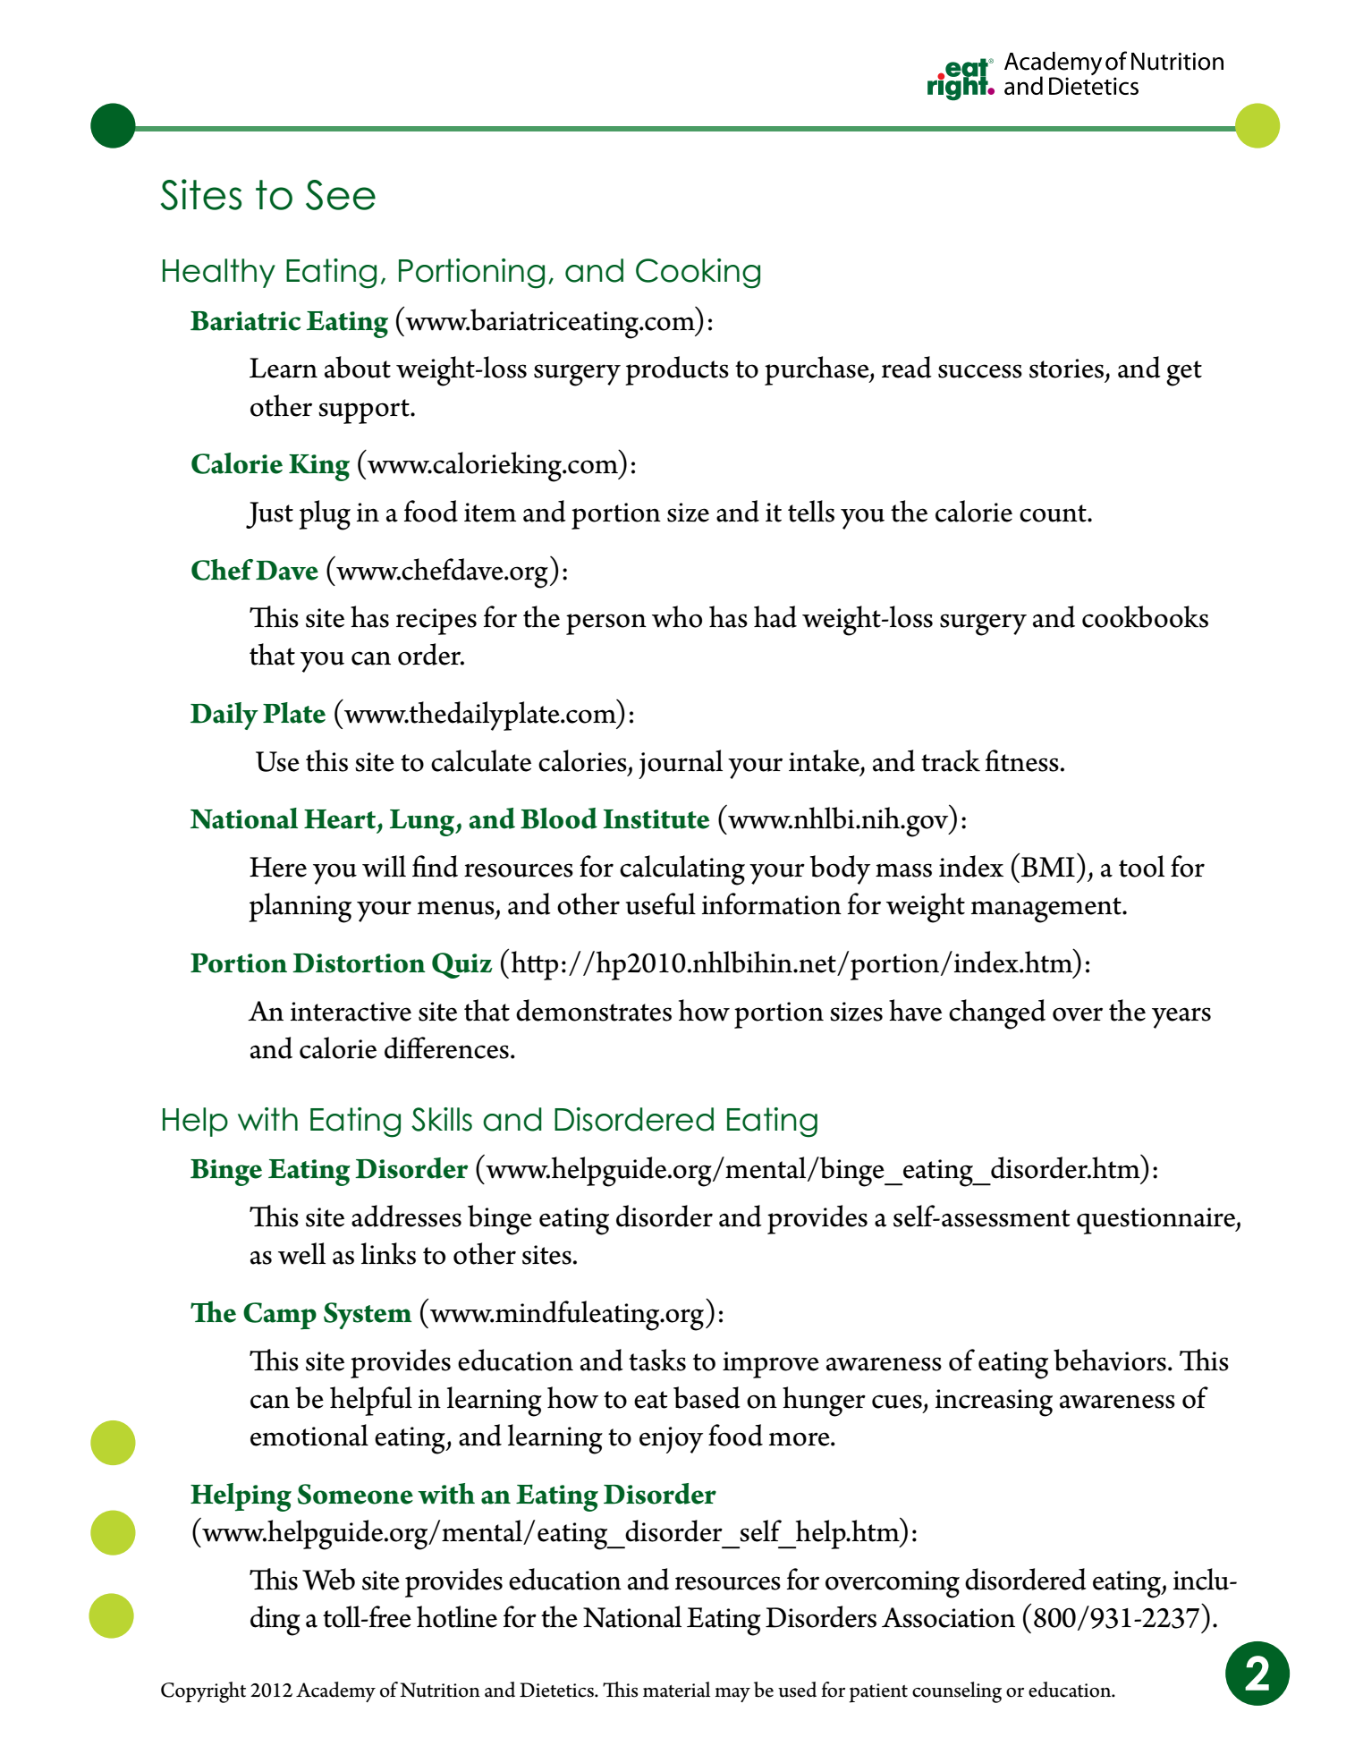

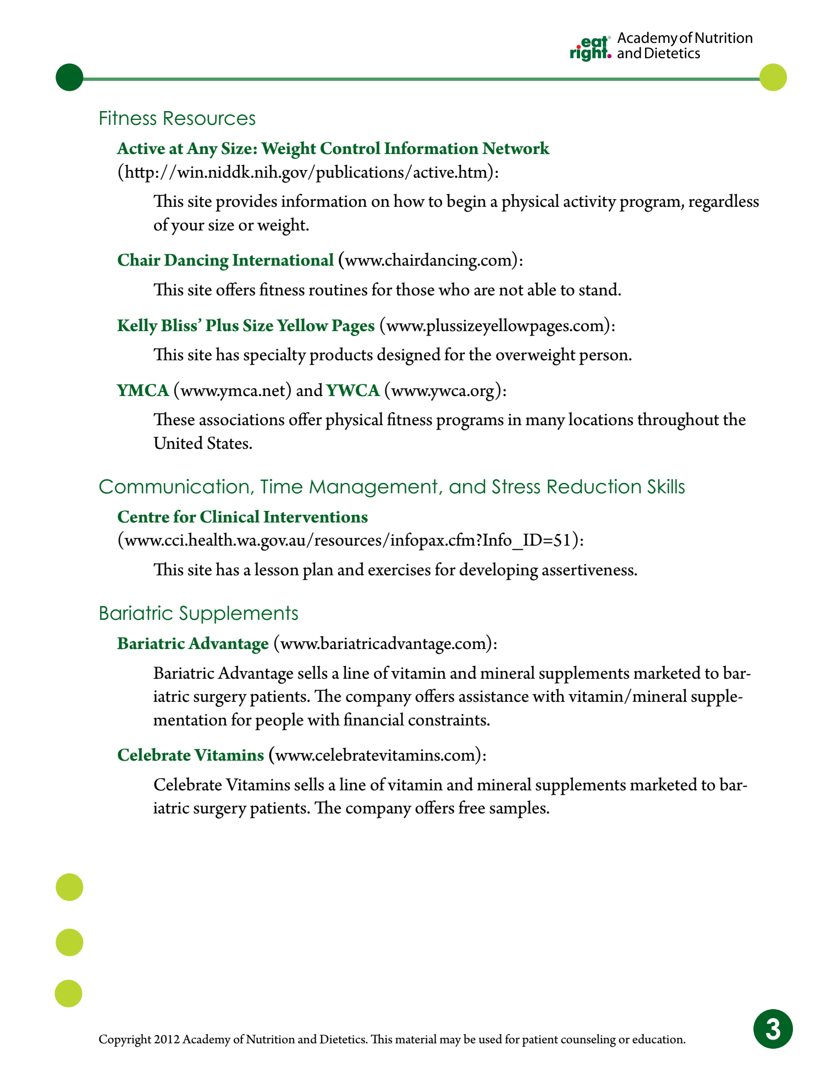


Support Groups
Support group is an important part of your weight-loss journey.
We encourage participation for all of our patients however there is NO penalty for not attending.
There are two support group classes for non-surgical patients & two support group classes for surgical patients each month.
Unless otherwise announced (i.e for weeks with holidays in them), meetings will take place either on-line or in the office conference room on the following days and times:

WEDNESDAYS
1st Wednesday: NO SUPPORT GROUP
2nd Wednesday via Zoom from 5:00-5:30 pm *Catered to Non- Surgical Patients.
3rd Wednesday: NO SUPPORT GROUP
4th Wednesday via Zoom from 5:00-5:30 pm * Catered to Surgical Patients.
There will not be a meeting if there is a 5th Wednesday in the month.
We may offer the in-person option if patient’s depending on the provider and requests for this.
We have gone back to separating the surgical & non-surgical patients in an effort to offer enhanced program structure & consistency for each group of patients. No one will be penalized in any way for not participating in these. Simply attend when you are able to with your respective group. Both surgical and non-surgical patients may attend both types of groups if they wish to do so. Contact the office if you have questions please.

https://atlanticgeneral.zoom.us/j/93872121574
Meeting ID: 938 7212 1574
One tap mobile
+19294362866,,93872121574# US (New York)
+16699006833,,93872121574# US (San Jose)
Dial by your location
+1 929 436 2866 US (New York)
+1 669 900 6833 US (San Jose)
*Please do not hesitate to call or contact our office for any questions or concerns at 410-641-9568.
Thank you

