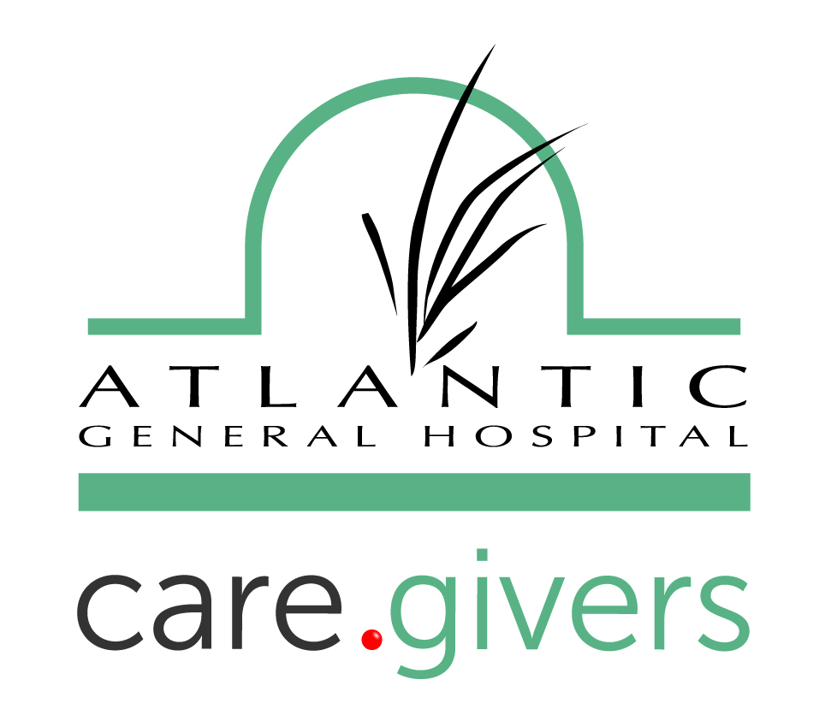 | About the AGH New Direction Medical Weight Loss Program  a service provided by the Atlantic Bariatric Center
Obesity is a major health risk that is serious and costly. According to the CDC, more than three in five American are overweight. One-third is obese. Obesity related conditions include heart disease, high blood pressure, high cholesterol, stroke, type 2 diabetes, and certain types of cancer. Like other chronic diseases, obesity requires responsible, comprehensive treatment, including ongoing care.
A New Option for Weight Loss
The AGH New Direction Medical Weight Loss Program provides the treatment needed to achieve long term success. The goal is to help our associates achieve permanent weight loss through life long changes in dietary, behavioral, and activity patterns.
We provide customized diets tailored to each individual’s weight loss goals. These diets will be supervised by a nurse practitioner, dietitian, and behavior specialists. Education will be provided about health, nutrition, exercise and positive behaviors. There will be weekly weight monitoring along with periodic lab tests, and EKGs. We will offer professional and peer group support and education to help form new eating and exercise habits that promote weight management skills.
Whether you want to lose a lot of weight or those last 10 pounds, we can help.
The AGH New Direction Medical Weight Loss Program is provided by the Atlantic Bariatric Center. Atlantic General Hospital and Health System associates have the opportunity to take advantage of the service, supported by the Associates Getting Healthy Wellness Program, before it is rolled out to the general public.
Frequently Asked Questions
Q. What kind of diet will I follow?
A. During the weight loss phase you will follow a very low calorie diet consisting of delicious drinks and bars specially formulated to provide the necessary proteins, carbohydrates, vitiams and minerals that you need. These foods will supplement one lean/green meal of your making daily.
Q. What are the health benefits of the program?
A. Weight loss can improve, reverse or even prevent serious medical conditions, including type 2 diabetes, high blood pressure, cardiovascular disease and high cholesterol. It can also reduce joint and back pain, and dramatically improve your energy and mood.
Q. How do I know which diet plan is best for me?
A. AGH New Direction staff will take into account your BMI, weight loss goals and health status to determine the appropriate diet plan for you.
Q. How much weight can I expect to lose?
A. This may be everyone’s top question! It depends on several factors including your weight, age, gender, and activity level. A loss of four to seven pounds is common during the first week. Ongoing weight loss is typically about three pounds a week.
Q. How much does the program cost?
A. There are several price components of the program.
- A program fee of $150 will be due at signup. This fee covers weekly weights, education and support group sessions.
- Depending upon your needs, the program drinks and bars should be no more than $40 a week for breakfast, lunch and snacks. That’s less than $3 a meal.
- Patients will need to provide co-payments and/or co-insurance fees for any necessary physician checkups, nutrition consultations, blood work, and EKGs as determined by the program administrators.
Q. It might be hard for me to pay for the program fee all at once. Do I have options?
A. Absolutely! Speak to someone at the front desk about payment options.
Q. But, still, that seems expensive. Is it worth it?
A. Motivated individuals who stick with the program find it to be well worth the investment. The cost, both financially and physically, of the complications and disease risks tied to being overweight, are much greater than the cost of the medical weight loss care provided through AGH New Direction.
Q. When does the program start?
A. Each individual person decides when it is best for him or her to start.
Q. How do I enroll?
A. Call or e-mail Angela Simmons, CRNP, CBN, Bariatric Coordinator, at 410-641-9568 or asimmons@atlanticgeneral.org to begin the enrollment process.

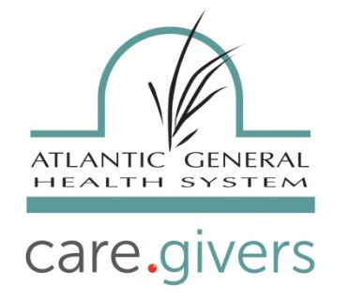
THE NEW DIRECTION MEDICAL WEIGHT LOSS SYSTEM
*The New Direction System is a medically supervised weight loss management program that has been helping patients to lose weight for almost 20 years.
*The program offered by Atlantic General Hospital is tailored by our bariatric team to meet each patient’s individual & unique needs. It is a medically based program for patients who are supervised & managed by our medical director, Dr. Zarif, our nurse practitioner, Angela Simmons, CRNP, CBN, Bariatric Coordinator, & our registered dieticians, Amy Gehrig, RD, & Amanda Buckley, RD. Our staff also keeps close contact with our patient’s primary care providers as well.
*The program approaches individual weight loss goals in stages.
- Stage 1: Screening. Patients are medically screened to see if it is safe for them to participate in the New Direction program. The screening process includes a physical examination, review of medical history & laboratory testing.
- Stage 2: Reducing. (Active weight loss) Using the system’s nutritional products, participants begin to learn & practice weight management skills without the influence of food.
- Stage 3: Adapting. (Transitioning to grocery food) Practicing newly acquired eating & exercise habits, participants gradually return to grocery meals while still allowing them to stay in control of their eating.
- Stage 4: Sustaining. (Maintenance) Continuing support using relapse prevention & individualized meal plans to help patients live a healthier lifestyle.
*The program uses a Very Low Calorie (as low as 800-1000 calories daily) or Low Calorie (typically 1000-1200 calories daily) diet approach to achieve weight loss goals. High quality dietary supplements are prescribed to each of our patients after assessing their individual needs.
*The structure of the program focuses on empowering patients. Weekly staff-lead support groups & peer support helps patients form new eating & exercise habits thus promoting better weight management skills.
*Benefits of the program boast improvement of comorbidities as well as feeling great!

InsuranceGuidelines

Coverage for weight loss surgery and preparation for surgery vary greatly from policy to policy. This document is designed to help you determine your level of coverage and the requirements of your individual plan. Start by calling the number on the back of your insurance card. Ask to speak with a “benefits” representative or someone about “pre-authorization” for bariatric services.

Insurance Company/Representative’s Name: _________________________ Policy Number: ________________

- Ask the representative to look up your particular policy by your policy number.
Does my policy cover Non-surgical Bariatric services (Provider visits & labs)Yes / No

- If the answer is No, ask if there are any exemptions for medical reasons such as Diabetes, High Blood Pressure, High Cholesterol, or other medical issues.

- What are the requirements to be authorized for coverage?

- Do I need supervised weight loss attempts with a Dietician? Yes / No
- If Yes, for how long? ____________________Do they need to be consecutive? Yes / No

- Do I need any specific studies? (i.e. UGI) Yes / No

- Do I need to journal food/exercise? Yes / No

- Do they cover Nutritionists/Dietitian visits? Yes / No
- If the answer is yes, do they cover services provided by Atlantic General Hospital? Yes / No

- Does insurance cover medical supervision of treatment programs? Yes / No

- Do I need referrals for initial consultation with the nutritionist, or other providers? Yes / No

New Direction Patient Contract/Agreement
I, _________________________ wish to enroll in the New Direction medical weight loss program through Atlantic General Hospital.
I, the patient understand & agree to the following:
- I am committing to making necessary lifestyle changes required to lose weight. This will likely be difficult, but I know it is worth my effort, time, & money.
- It may take a long time to reach my goal. I did not become overweight in a week or month, & cannot expect to lose my excess weight in that amount of time. I must be patient with myself & my providers along this journey.
- My health care team will not judge me. They are here to provide me with the resources & guidance I will need to be successful, to give me encouragement & reassurance when I need it.
- I will try to focus on the positive. Always. When I am struggling, I will reach out to my team.
- This is a life-long commitment I am making to myself.
- In order to succeed I will need to attend regular visits with the Registered Dietician, & Nurse Practitioner. I will also be required to undergo initial lab & EKG testing, then routine lab monitoring every 4 weeks at the discretion of the Nurse Practitioner in order to ensure my safety & health throughout my program.
- I also understand that I must attend weekly support groups which focus on nutrition or behavioral modification or exercise. I must commit to attending at least 2 out of 4 meetings per month to be able to learn new information & how to implement changes.
- I will purchase the ND products for my own use, & understand that these are not returnable.
Our Commitment to you: The Bariatric Team at AGH pledges to empower you with knowledge & skills necessary to take control of & responsibility for your own weight management in a safe, effective, & dignified manner. We will do our best to support all of your efforts to lose weight in a way that is fashioned & tailored to your individual needs & desires.
Patient Signature: _________________________
Bariatric Coordinator Signature: _________________________

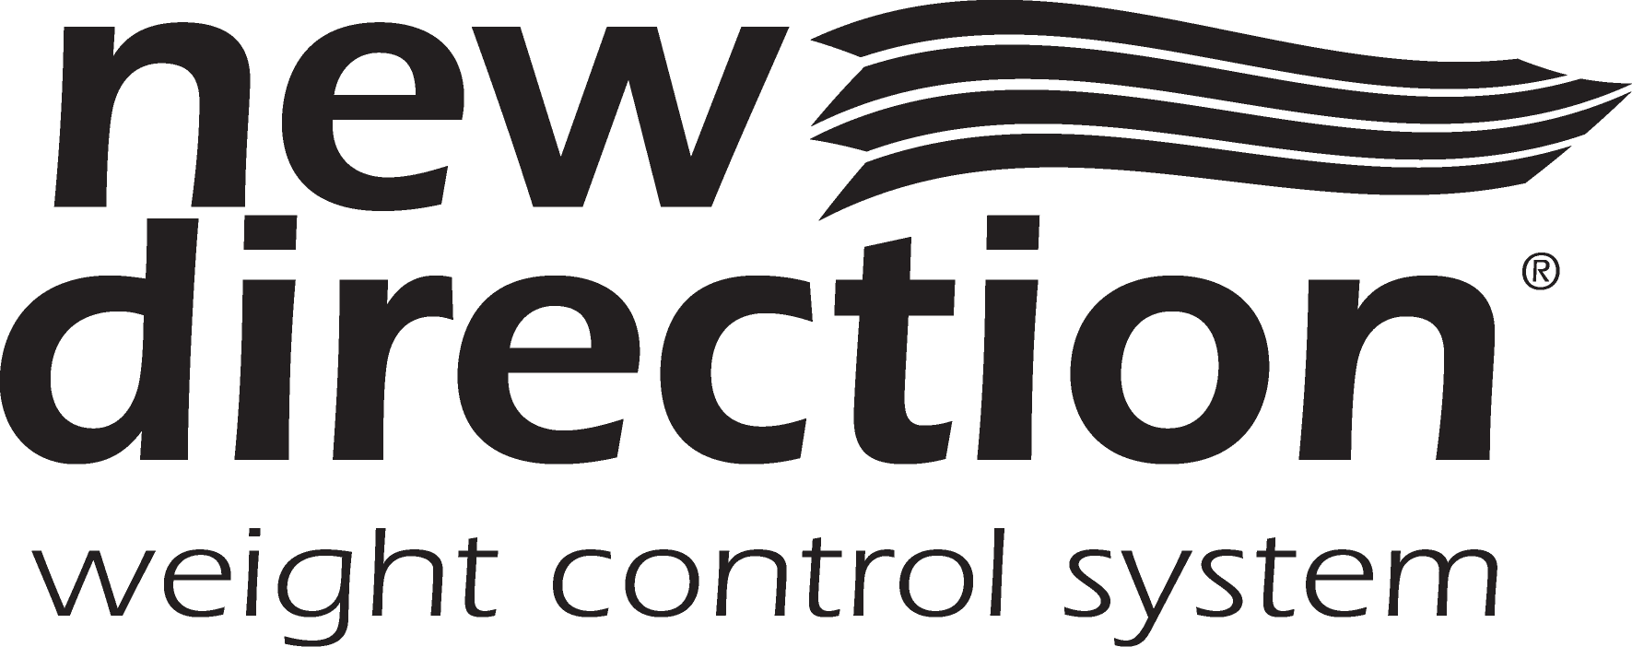
Treatment Consent Form

AUTHORIZATION FOR EXAMINATION AND TREATMENT

1. Having been explained the risks and benefits of the NEW DIRECTION WEIGHT CONTROL PROGRAM (“Program”) a medically monitored Program for rapid, safe* weight loss and complete education to help manage weight. I knowingly and voluntarily desire to participate in the Program.

2. I am aware that I must meet medical and psychological screening criteria established by the NEW DIRECTION team of weight management professionals before entering the Program.

3. I hereby authorize and consent to have Program physicians perform complete physical, and diagnostic procedures including blood test, electrocardiogram (“EKG”), and possibly a stress test and/or chest radiography for evaluation purposes. I have had the opportunity to ask questions regarding the diagnostic procedures.

4. As part of the NEW DIRECTION WEIGHT CONTROL PROGRAM continuous medical monitoring is mandatory. Consequently, upon acceptance to the Program, I willingly agree to have this monitoring performed (blood tests, periodic EKG, and other tests as indicated).

5. I am aware during the fasting period possible side effects may occur from ketosis. Ketosis is an increased amount of fat by-products (ketone bodies) in the body due to altered nutrient composition of the diet (low carbohydrate). These side effects include dizziness and fruity breath. Less common, but possible side effects are fatigue, leg cramps, missed or late menstrual periods, dry skin, temporary hair loss, sensitivity to cold, diarrhea, and constipation.

6. I have been informed that foot-drop is a rare transitory side effect of weight loss.

7. I have been informed that any weight loss regimen increases the chance of gallstone formation.

8. If medical complications unrelated to weight loss arise during the Program, I am fully aware I will be referred back to my private physician for treatment and evaluation.

9. I recognize that if I should become pregnant my participation in the (if applicable) Program must be terminated.

10. I understand that I will pay for my Products and Program services on a weekly basis. I understand that it is my responsibility to pay for these services myself, but that (hospital name) will assist me in applying for reimbursement from or through any available insurance coverage, which I may have and will provide, necessary and pertinent information requested in connection with any applicable insurance coverage. However, I understand that I am fully responsible for payment of the entire charges regardless of whether I have or believe I have insurance coverage, which would apply.

11. The NEW DIRECTION team of weight management professionals has answered my questions regarding this Program and possible side effects.

12. No guarantee has been given to me by anyone as to the results that may be obtained.

13. Having been advised of the above, I authorize and consent to the performance of the procedures and other treatment of the Program.

* Physician monitoring is required to help minimize the potential for health risks.

_________________________________________ ___________________________________________
Participant Date Witness Date

**Affirmation by Physician. The matter set forth above has been explained by me to the signor of this form

Name: Date of Birth:
Nutrition Assessment Form
Age:
E-mail Address: ______________________________ Phone: ______________________

Live with: ☐Spouse ☐Family ☐Friend ☐Alone

Employment: ☐Full-Time ☐Part-Time ☐Retired ☐Student ☐Other ____________

Occupation: ____________________ Work Hours: _____________

Have you seen a dietitian before? ☐Yes ☐No
If yes, for what diet? _______________ When? __________ Where? __________

Have you had any previous weight loss surgeries? ☐Yes ☐No
If yes, what type(s)? ____________________________ When? _______________

Diets/Weight plans tried in the past:_________________________________________________________

_______________________________________________________________________________________

Height: _______ Present Weight: _______

Highest Adult Weight/Age: _______________ Lowest Adult Weight/Age: ____________________

Recent weight change? ☐Yes ☐No How many pounds lost? _______ Gained? _______

What would you like to weigh? _______

What age did you begin to gain excess weight? _______

Looking back, what would you attribute the weight gain to at that time? ______________________

____________________________________________________________________________________
What is the main reason you have been unable to lose weight (or maintain lost weight)? __________
______________________________________________________________________________________

Please check if you are currently taking any of the following:
☐ Multi-vitamins: brand: _____________________________________
☐ Single Vitamins (Vitamin C, E, etc): type(s): ______________________________________________
☐ Calcium: type: ____________________________ amount: __________________________________
☐ Herbs: type(s): ______________________________________________________________________
☐ Other: _____________________________________________________________________________

Food Allergies/ Intolerances:
Please check (✓) everything below that describes your eating pattern and/or lifestyle behaviors:
 | - I eat large portions, get seconds or overfill my plate |  | 11. I don’t take time to plan healthy meals  ahead
 | - I skip meals or go for longer than 5 hours between meals |  | 12. I am tempted by family/friends to eat  unhealthy foods
 | - I dine out (includes carry-out) more than 3 times a week |  | 13. I lack the knowledge to cook healthy
 | - I frequently eat fried foods, fast foods and high fat foods |  | 14. I never feel “full” or satisfied after eating
 | - I frequently eat sweets and desserts  (candy, cakes, cookies) |  | 15. When dieting, I go to extremes
 | - I graze (snack on food all day long while doing other things (reading, watching TV, computer work) |  | 16. I drink less than 64 ounces (8 cups) daily  (all fluids count)
 | - I eat too quickly |  | 17. I usually drink two or more alcoholic  beverages daily
 | - I am an emotional eater (I eat when I am stressed, bored, anxious…) |  | 18. My work schedule hinders my weight loss  efforts
 | - I am so busy, I forget to stop and eat |  | 19. I would have a difficult time reducing or  giving up: _____________________
 | - I am a “picky” eater |  | Other:

Goals & Readiness Assessment

- I want to lose weight because:
___________________________________________________________________________________
___________________________________________________________________________________
- My nutrition-related goals are:
___________________________________________________________________________________
___________________________________________________________________________________
___________________________________________________________________________________

- If I could change 3 things about my health & nutritional habits, they would be:
___________________________________________________________________________________
___________________________________________________________________________________
___________________________________________________________________________________

- The biggest challenge(s) to reaching my nutrition/weight loss goals are:
________________________________________________________________________
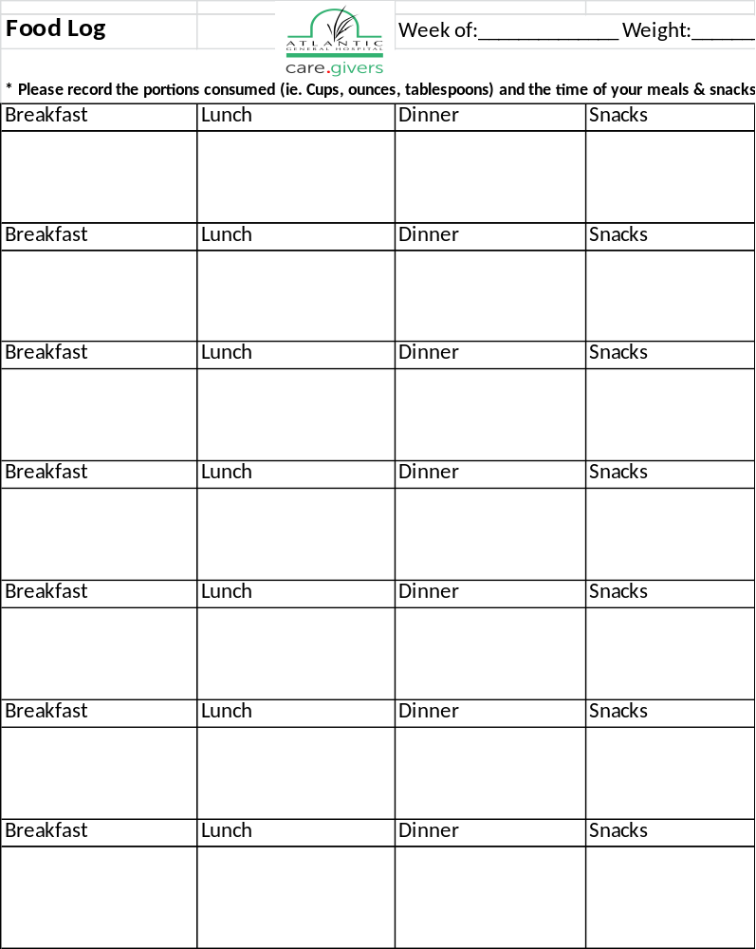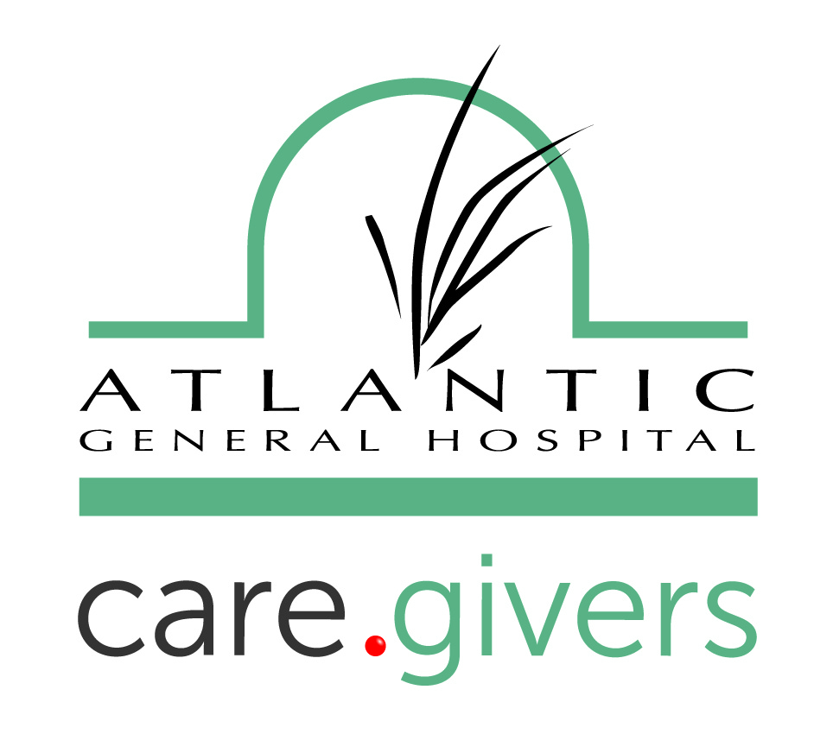
Support Group

Support group is an important part of your weight-loss journey, this is also where you will pick up your protein drinks & bars for the next week.

Meetings will take place in the office conference room on the following days and times:

TUESDAYS

5 PM
Or

WEDNESDAYS

12 PM

Please call 410-641-9568 if you have any questions or concerns.

CONSENT FOR PUBLICITY RELEASE

Atlantic General Hospital, Berlin, Maryland

DATE: ___________________ TIME: ___________________

NAME OF PATIENT, PHYSICIAN, ASSOCIATE, OR VOLUNTEER:

Permission is granted to use the name and/or photograph of the above in connection with publicity for Atlantic General Hospital/Health System.

DO NOT SIGN THIS FORM UNLESS YOU HAVE READ IT, UNDERSTAND IT AND AGREE WITH WHAT IT SAYS.

Patient/ Physician/ Associate/ Volunteer or Guardian Signature:
____________________________________________

Patient/ Physician/ Associate/ Volunteer or Guardian Print Name:
____________________________________________

Relationship of Guardian to Patient: _________________________________

Witnessed By (Please provide Signature): ________________________________

Please Print Name of Witness: ____________________________________

*The patient must sign this consent unless he or she is
- Incompetent B- under 18 and unmarried
*Signature by a legal Guardian or Representative must be obtained in the event the patient
is unable to sign this consent due to A and/or B.
Save Money While You Lose Weight
How the New IRS Policy Can Help You Deduct
the Cost of Your Weight Loss Program
Q: What is the new IRS policy, and what does it mean to me?
A: The IRS states, under “Medical and Dental Deduction” in Publication 502, that “you can include in medical expenses the cost of a weight-loss program undertaken at a physician’s direction to treat an existing disease (such as heart disease) . . . ” This is good news for you if you pay out-of-pocket for your weight loss program.
Q: Am I eligible?
A: You’re eligible if you meet the following criteria. First, your doctor must direct you to lose weight to help improve an existing disease that is likely to benefit from weight loss treatment, such as heart disease, hypertension, high cholesterol or type 2 diabetes. Second, you’re eligible if you itemize your deductions or you have a Medical Savings Account (MSA) or Flexible Savings Account (FSA) through your employer. (FYI: Medical expenses are tax deductible if they exceed 7% of your adjusted gross income and are not reimbursed by health insurance agencies.)
Q: Which expenses can I deduct?
A: Thanks to the new policy change, you can now deduct a wide variety of costs associated with your weight loss program. You can deduct the services of physicians, dietitians, nutritionists, behavioral counseling, physician- and hospital-based weight loss programs, commercial weight loss programs, weight loss drugs and bariatric surgery.
Q: Which expenses cannot be deducted?
A: You cannot deduct health club dues, exercise equipment, over-the-counter diet aids, low-fat foods or dietary supplements.

A: Ask your doctor to write a note affirming that you have a disease that would benefit from weight loss treatment. Make sure he records the earliest date in the year 2000 that he diagnosed this disease. Keep receipts from all deductible weight loss program expenses. Consult with a professional tax advisor to see how to incorporate this information into your tax return and to discuss your individual situation.
Q: Will this new policy affect my private health insurance or Medicare coverage for obesity treatment using a weight loss program?
A: Some health plans do provide coverage for treating obesity—you’ll need to review the terms of your individual plan. Also, a new Medicare benefit makes Medical Nutrition Therapy (MNT) available to seniors to help them manage diabetes and kidney disease, and it establishes registered dietitians as Medicare providers. The American Dietetic Association will continue its campaign urging Congress to expand this MNT benefit to cover patients with heart disease, high cholesterol and other life threatening diseases.

